|  |  |  |
| --- | --- | --- |
| GAS PRODUCTION –  Time Series Forecasting    SUBMITTED BY – SANKALP RAJ MATTA |  |  |

CONTENT:

1. Project Objective
2. Importing the Time Series in R
3. Exploratory Data Analysis
4. Identifying the Components of the Time Series
5. Checking the Periodicity of the Time Series Data
6. Checking the Stationarity of the Series
   1. Using Augmented Dickey Fuller Test
   2. Using Visualization of decomposed series
7. Differencing the Time Series
8. Splitting the final time series into Train and Test parts
9. Checking ACF and PACF on Train set
10. Manual ARIMA Modelling
    1. Creating the Manual ARIMA model
    2. Visualizing the Model Fit
    3. Interpreting the Residuals
       1. Using Plots
       2. Using Box-Ljung Test
11. Auto ARIMA Modelling
    1. Creating the Model
    2. Visualizing the Model Fit
    3. Interpreting the Residuals
       1. Using Plots
       2. Using Box-Ljung Test
12. Forecasting On Arima Models
    1. Manual ARIMA Forecasting
    2. Auto ARIMA Forecasting
13. Selecting The Final Best Model
14. Using Final Model to forecast for unseen 12 months

# 1. PROJECTIVE OBJECTIVE

We are supposed to download the Forecast package in R. The package contains methods and tools for displaying and analysing univariate time series forecasts including exponential smoothing via state space models and automatic ARIMA modelling. We have to explore the gas (Australian monthly gas production) dataset in Forecast package to do analysing and forecasting for 12 months more using the best validated model.

# 2. IMPORTING THE TIME SERIES IN R

The dataset Gas is present in the Forecast Package.

The gas is already a time series. We’ll assign it to an object called data.

It initially contains data from 1956 to 1996.

Rcode:

data<- forecast::gas

Forecast is package in the R language. We download it to access the time series object gas from it

# 3. EXPLORATORY DATA ANALYSIS

It is done to understand the basic data structure as well as to visualize the dataset before performing any modelling.

* STRUCTURE- To find the structure of the Dataset.

str(data)

> str(data)

Time-Series [1:476] from 1956 to 1996: 1709 1646 1794 1878 2173 ...

* SUMMARY- Returns the details of the dataset regarding the measures of central tendency.

summary(data)

summary(data)

Min. 1st Qu. Median Mean 3rd Qu. Max.

1646 2675 16788 21415 38629 66600

• CLASS- Returns the class of the dataset object.

class(data)

> class(data)

[1] "ts"

## ➔ We have to use the data from 1970 onwards. So, considering the time series from (1970,1) till (1995,8)

gas = window(data, start=c(1970,1), end= c(1995,8))

plot(gas)

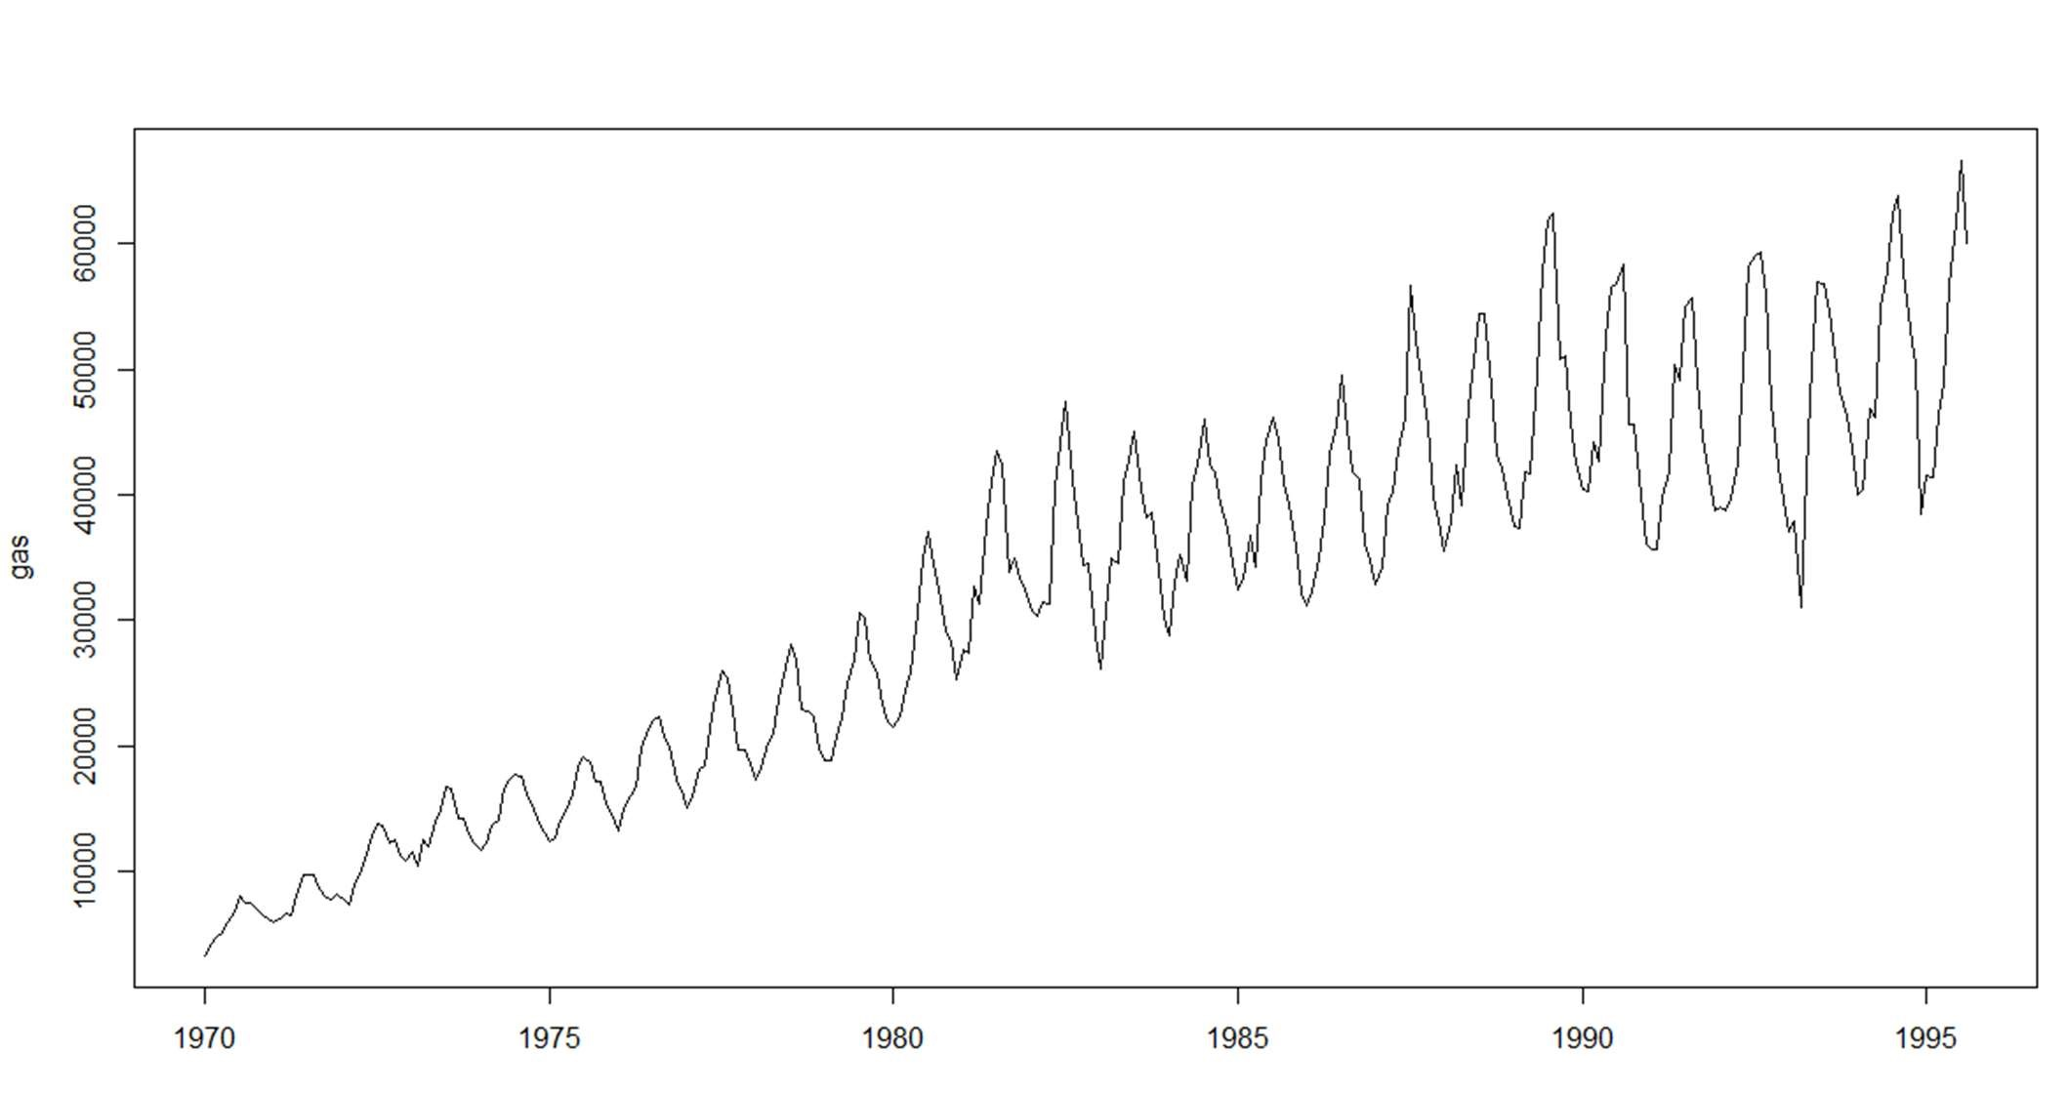

* MONTH PLOT- To visualize each month’s trend and seasonality individually

monthplot(gas)

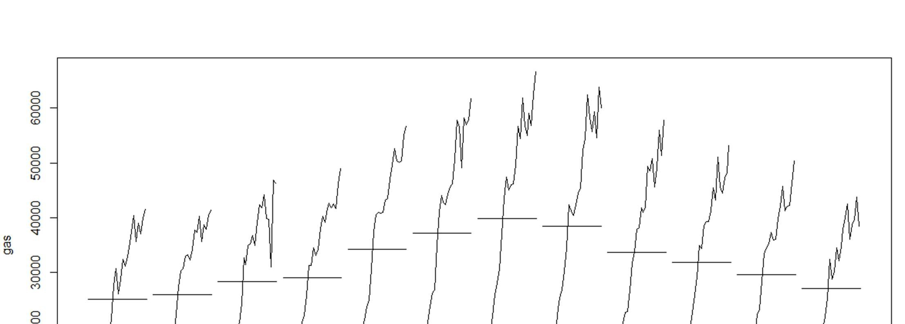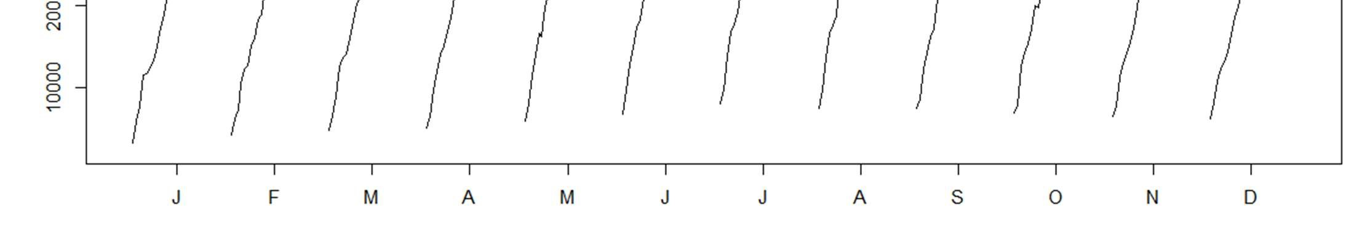

* SEASONAL PLOT – To visualize the seasonality from every perspective possible. ts_seasonal(gas,type = "all")

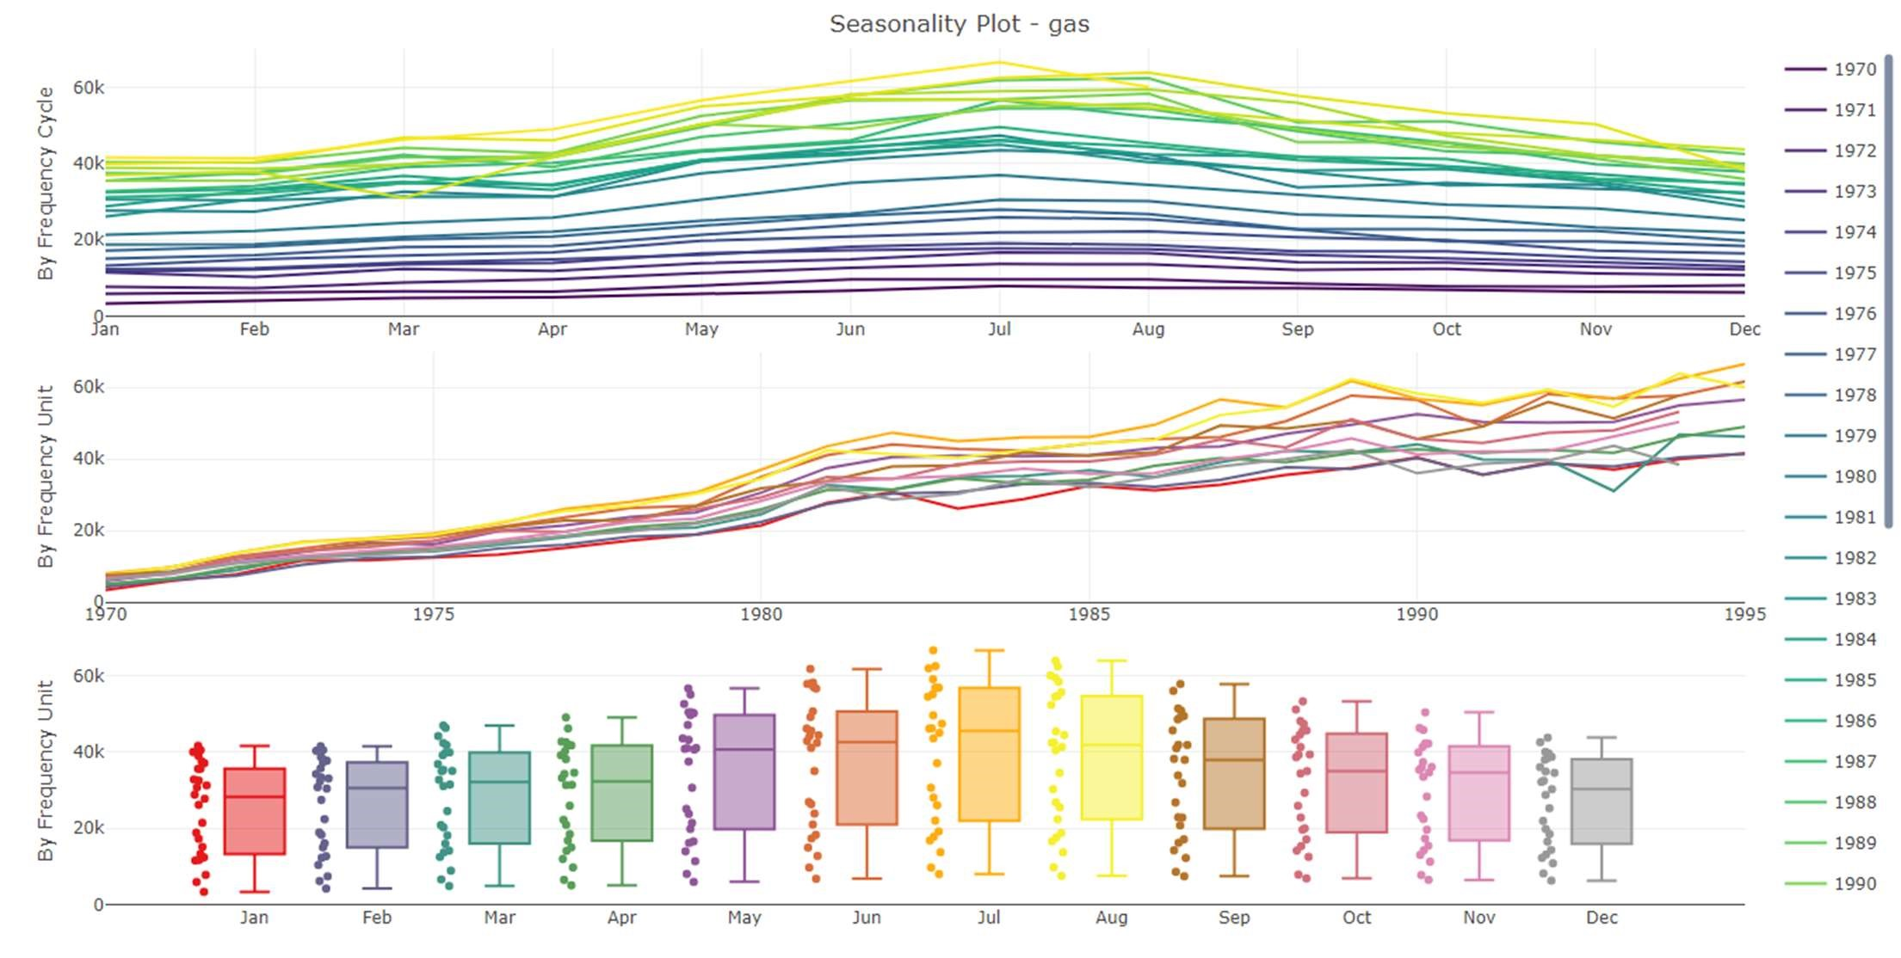

* BOXPLOT

This function will make the boxplots of all the month individually on a single chart.

boxplot(gas~cycle(gas), main = "Boxplot for Gas Dataset")

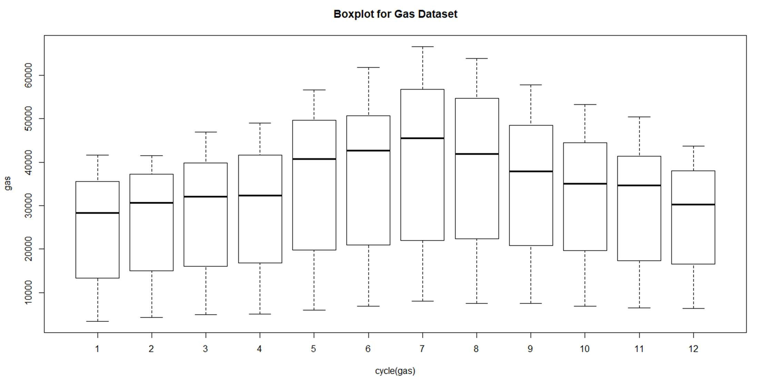

# 4. IDENTIFYING THE COMPONENTS OF THE TIME SERIES

There are in general three components of a time series:

* Seasonality
* Trend
* Residuals

Decomposition of the time series into its different components can be done using stl() .

RCode:

decomp_gas= stl(gas_production, s.window = "periodic") plot(decomp_gas)

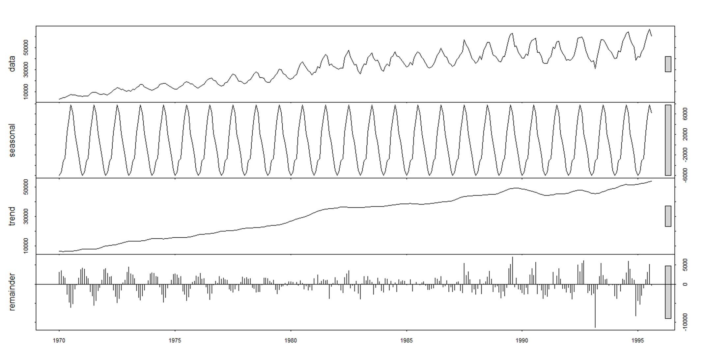

Here, we see that Trend plays a very big role in the making of this time series. The Residuals are also a significant part if our Time series. But there is no seasonality component in here. Therefore, we can say that only Trend and residual component are present in our time series.

# 5. CHECKING THE PERIODICITY OF THE TIME SERIES DATA

It is a fundamental characteristic of time series data. The frequency of observations against time.

> periodicity(gas)

Monthly periodicity from Jan 1970 to Aug 1995

Therefore, in this case, we can observe that there is monthly periodicity in this time series of gas data.

# 6. CHECKING THE STATIONARITY OF THE SERIES

6.1 Using Augmented Dicky Fuller Test

Formation of the Hypothesis of Augmented Dickey Fuller Test

• Null Hypothesis : H0: The time series is Non-Stationary • Alternate Hypothesis: H1: The time series is Stationary

adf.test(gas, alternative = "stationary",k=12)

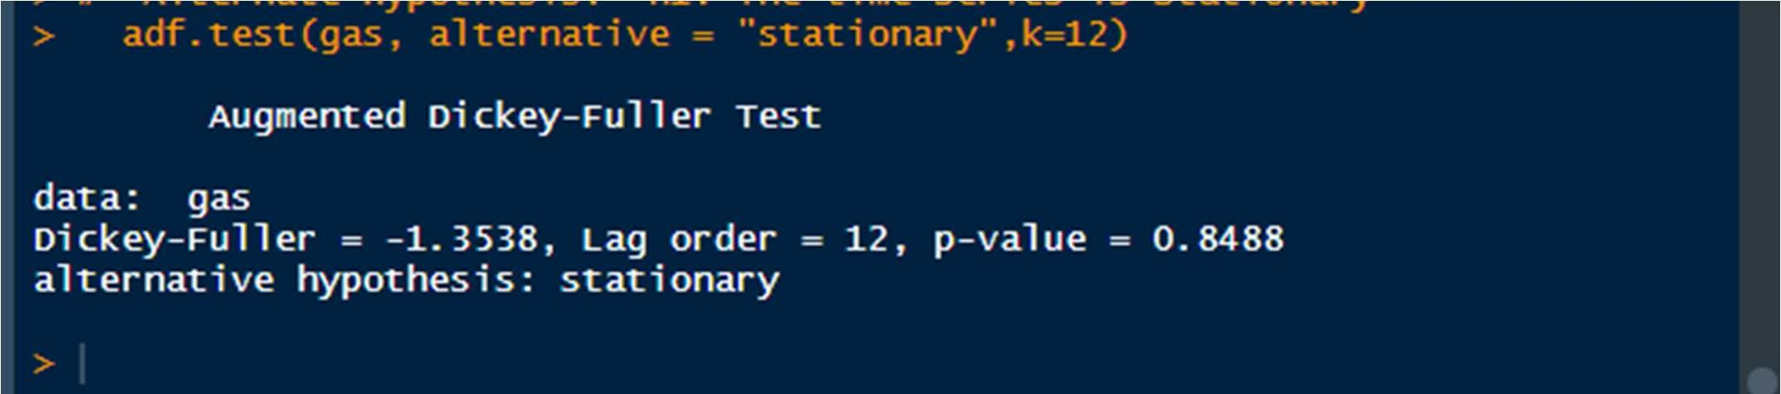

The p-value comes out to be .84 which is much bigger than the Alpha of 0.05.

Therefore, we fail to reject the null hypothesis of the series being non stationary. We'll accept the Null Hypothesis stating that the time series is non stationary.

6.1 Using Visualization Of Decomposed Series

plot(decomp_gas)

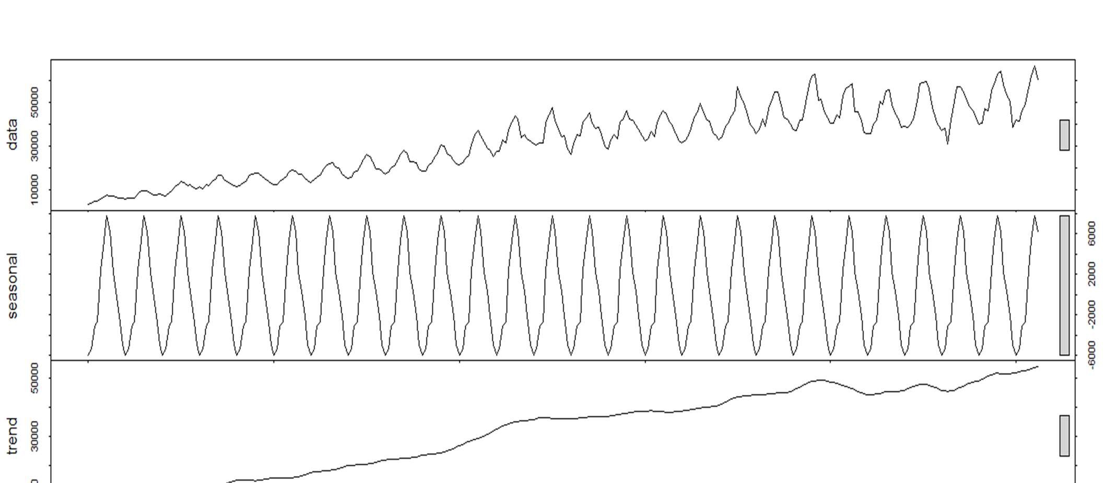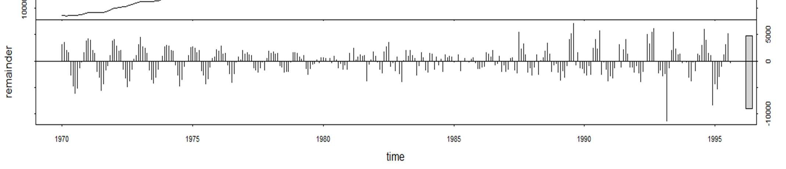

Had the series been stationary, there would have been no Trend or Seasonality. But there is a presence of Trend in the series. Therefore, also visually talking, the series is not stationary.

Therefore, we don't need to deseasonalize the time series because it’s already unaffected by the seasonal component.

The series is non-stationary.

## ➔ Checking The Auto Correlations Of The Time Series

Autocorrelation is the mathematical representation of the degree of similarity between a given time series and a lagged version of itself over successive time intervals.

* acf(gas, lag.max = 100)

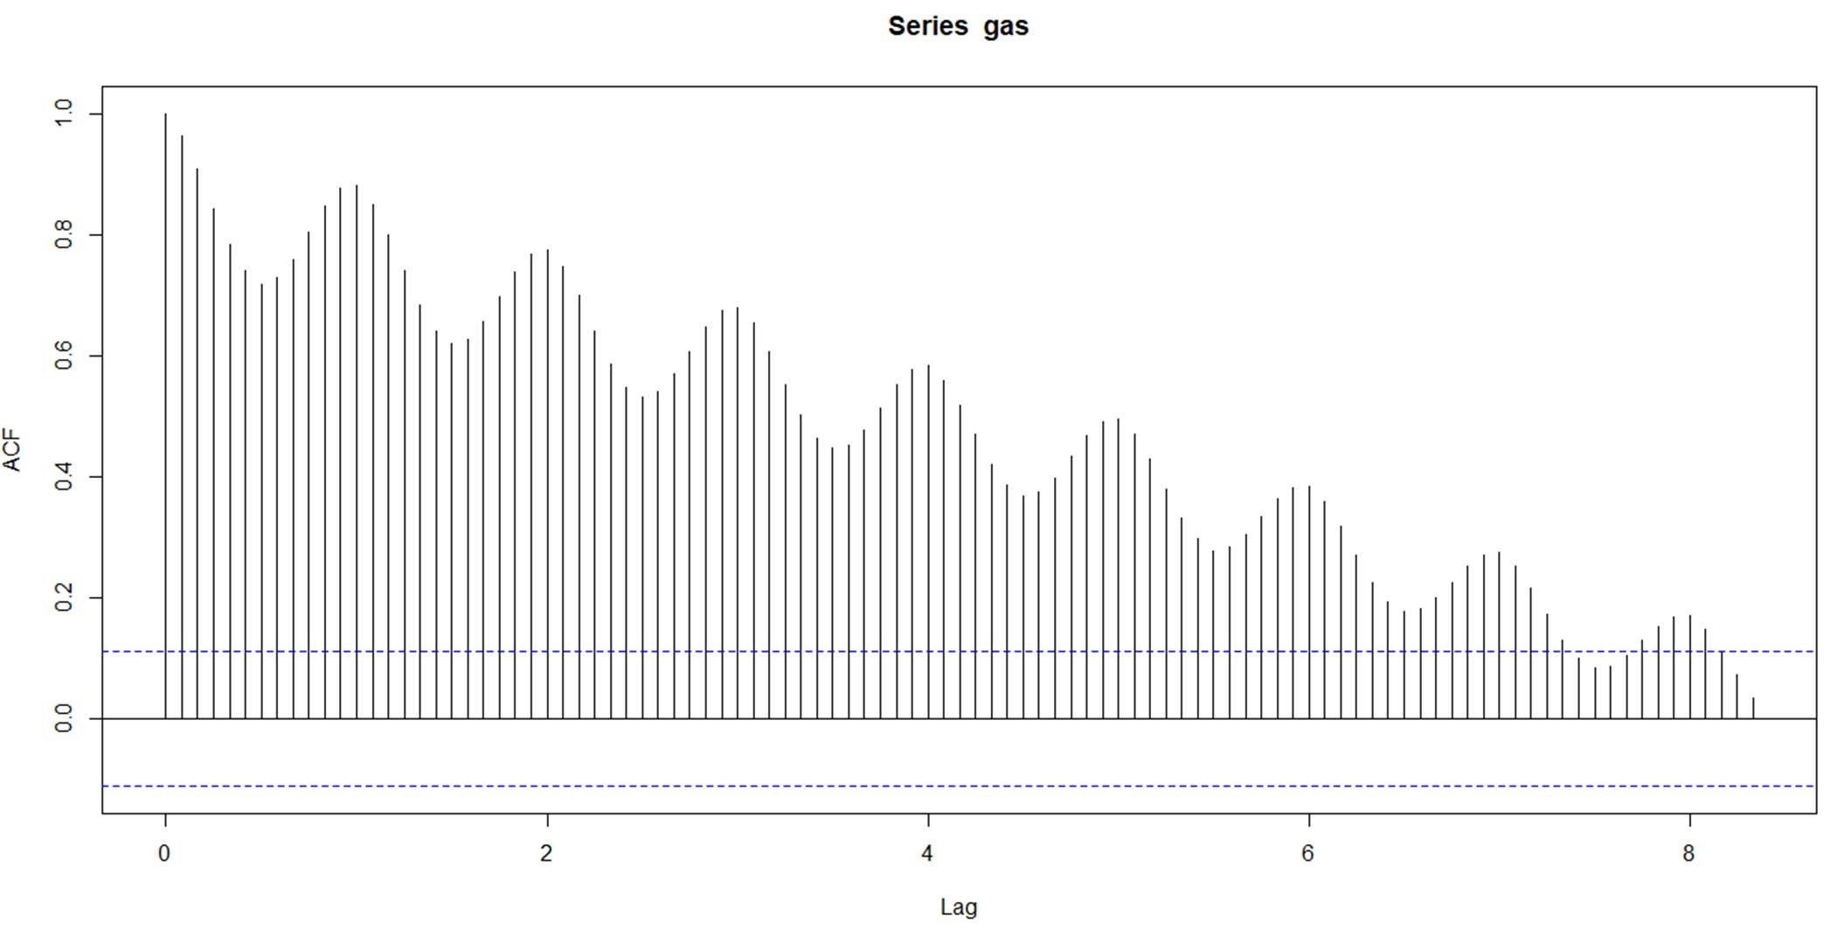

* pacf(gas,lag.max = 20)

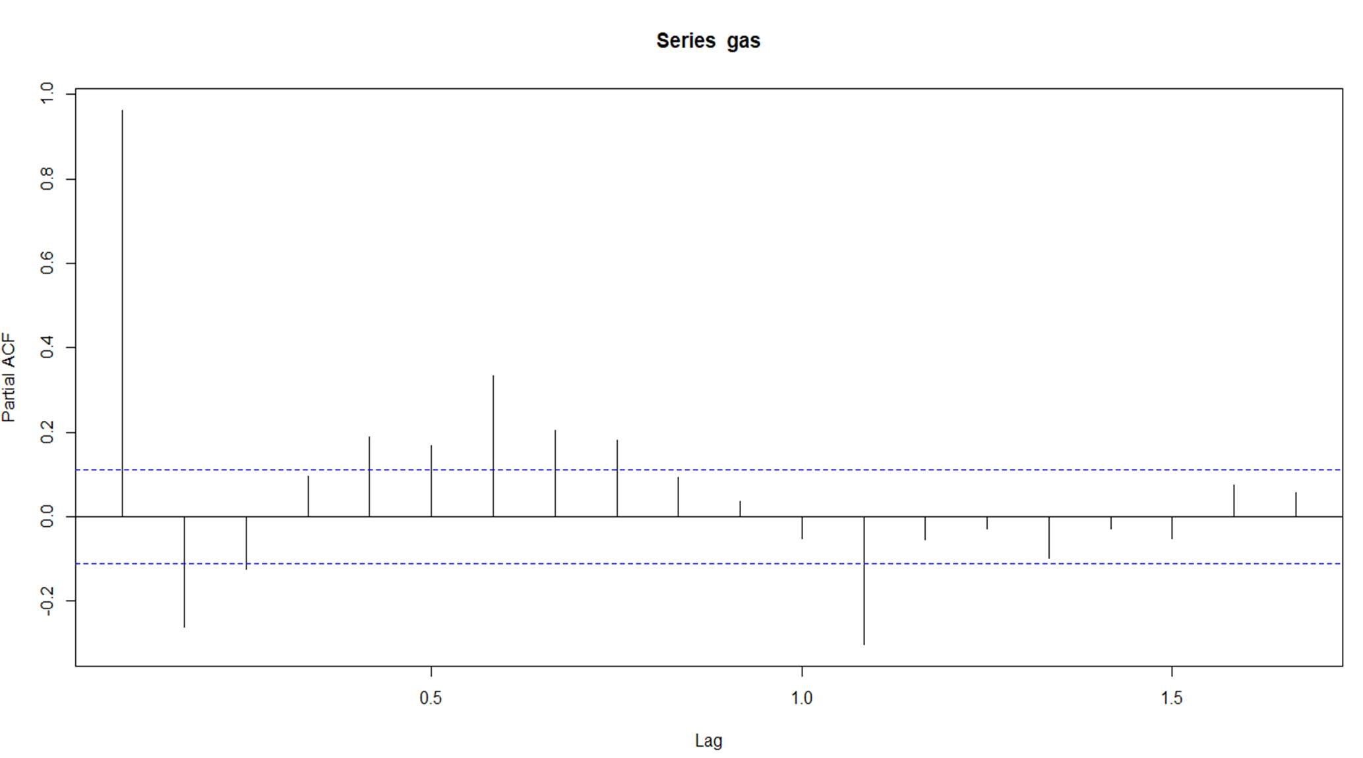

# 7. DIFFERENCING THE TIME SERIES DATA

A non-stationary time series can be converted into a stationary series by differencing the time series data. It is dne by subtracting the previous observation from the current observation.

Converting the time series into Stationary series.

RCode:

diff_gas= diff(log(gas), differences = 1) dygraph(diff_gas)

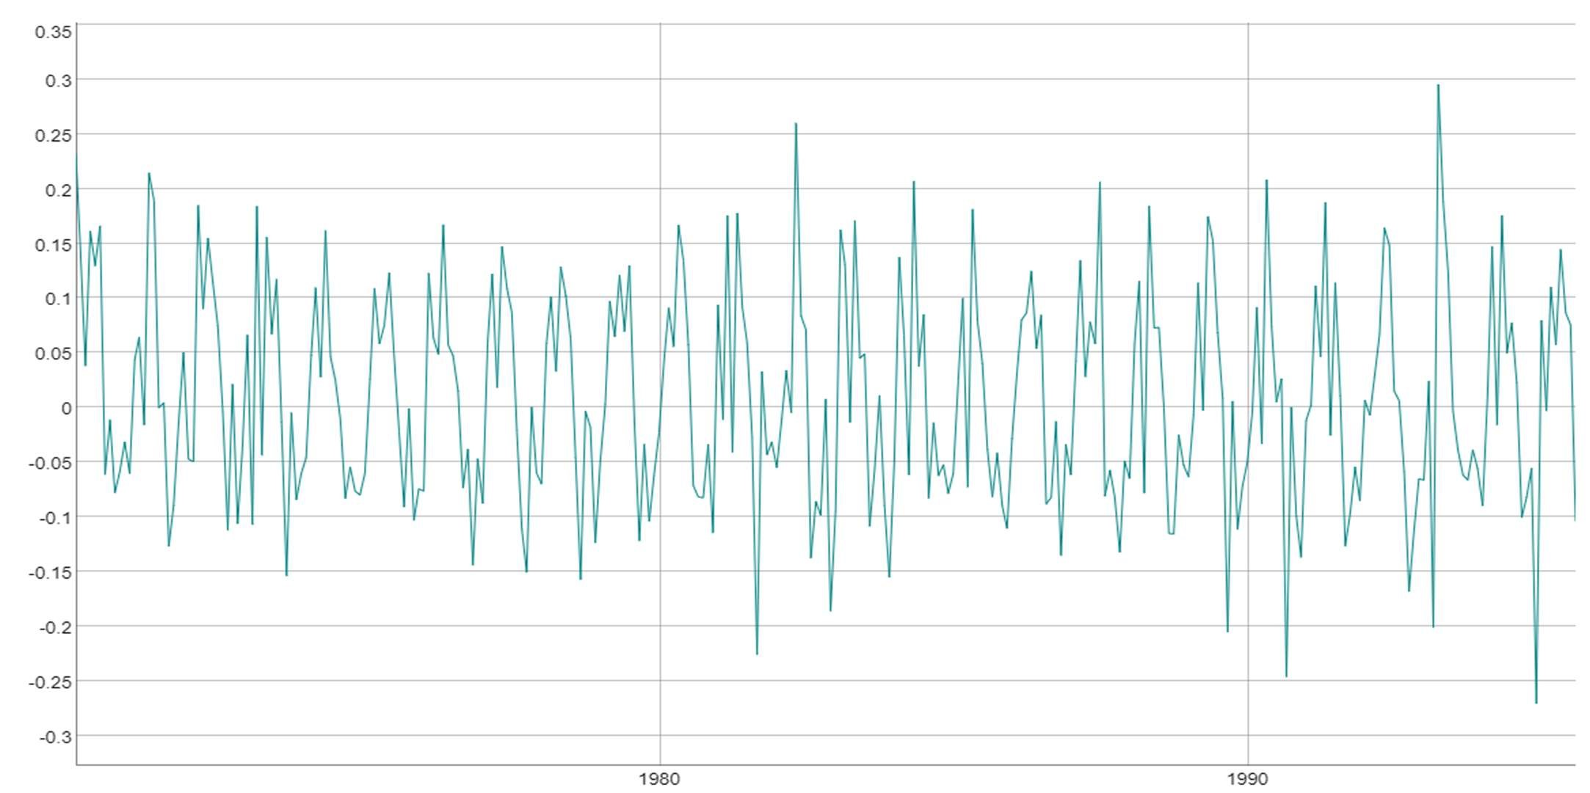

➔ Checking The stationarity of the Differenced Time Series:

adf.test(diff_gas, alternative = "stationary", k=12)

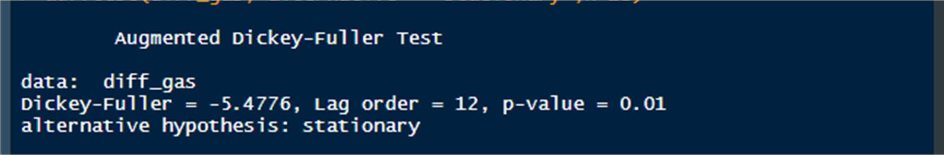

Here, we see that the p-value is much lower than our alpha of 0.05. Therefore, we know that if Pvalue is less than Alpha, then we reject the Null hypothesis and accept the alternative Hypothesis of the series being Stationary.

Hence, by doing the differencing of the time series one time, we are able to convert the nonstationary time series into stationary time-series.

➔ Now, we'll find out the ACF and PACF representations of the differenced time series.

* acf(diff_gas,main="ACF for Difference Time Series")

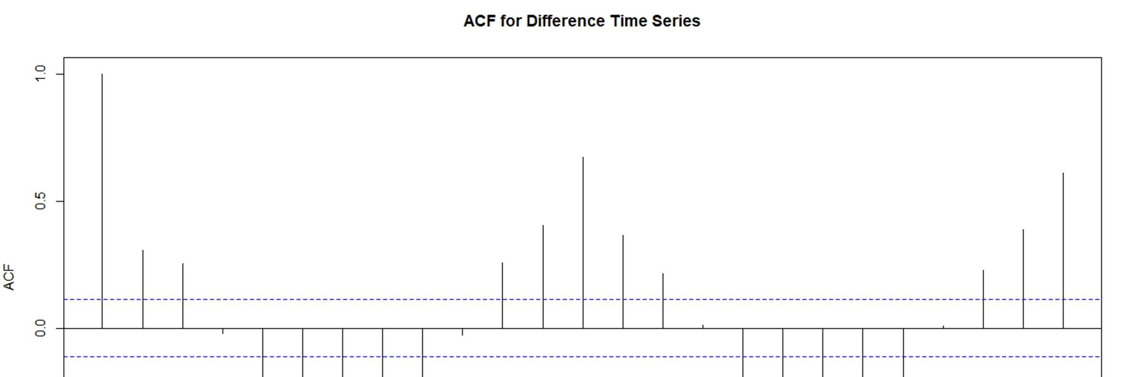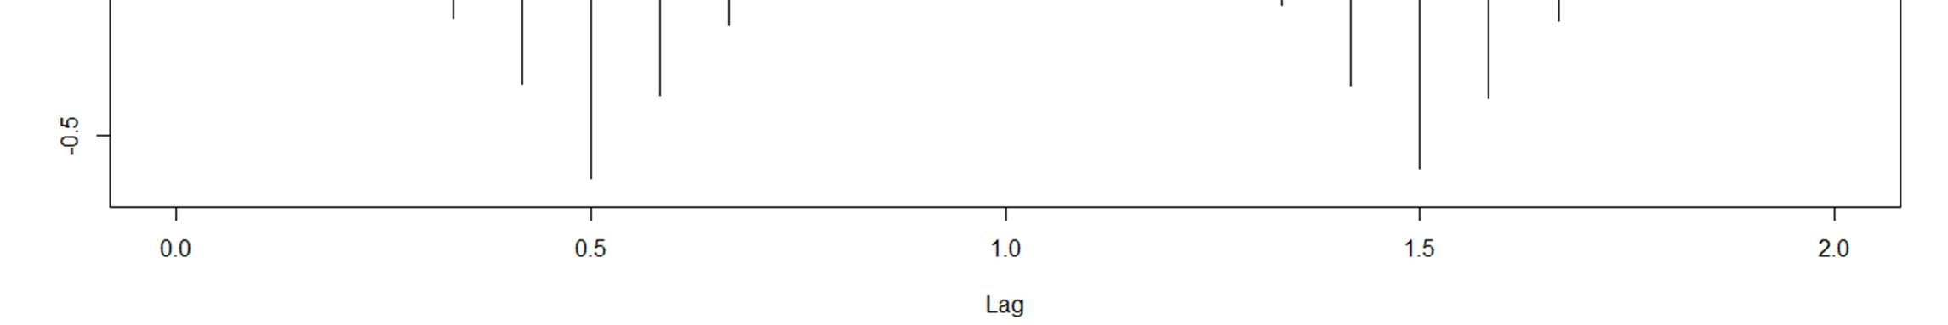

#Value of q= 3

* pacf(diff_gas,main="PACF for Difference Time Series")

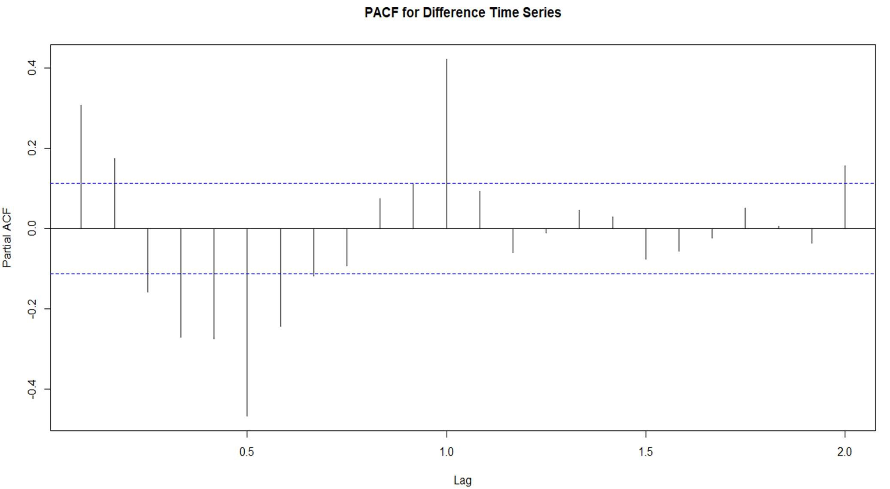

#Value of P= 2

# 8. SPLITTING THE TIME SERIES INTO TRAIN AND TEST PARTS

We'' use the data from Jan,1970 till Dec,1993 in the Training part. We'll use the data from Jan,1994 till Aug,1995 in the test data.

RCode:

train_gas= window(diff_gas,end= c(1993,12)) dygraph(train_gas)

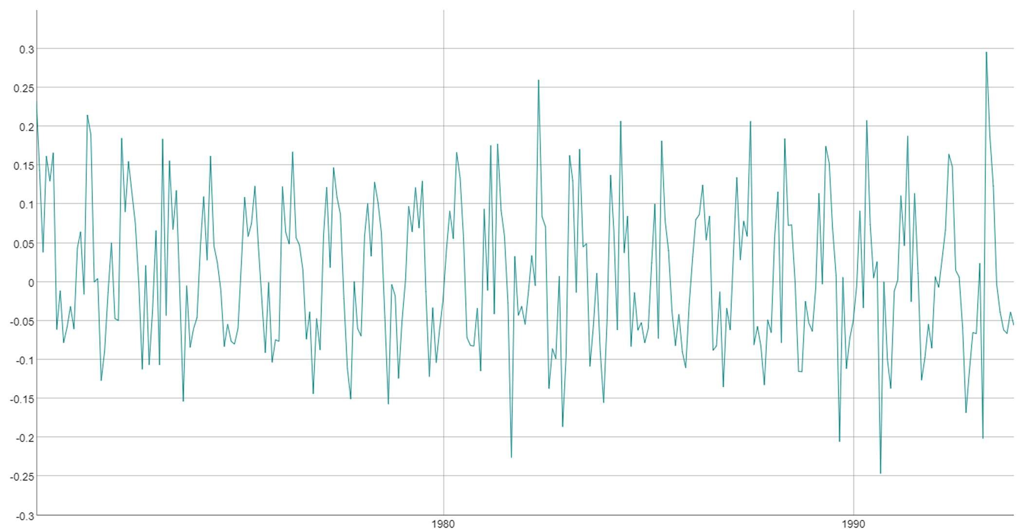

test_gas = window(diff_gas, start=c(1994,1)) dygraph(test_gas)

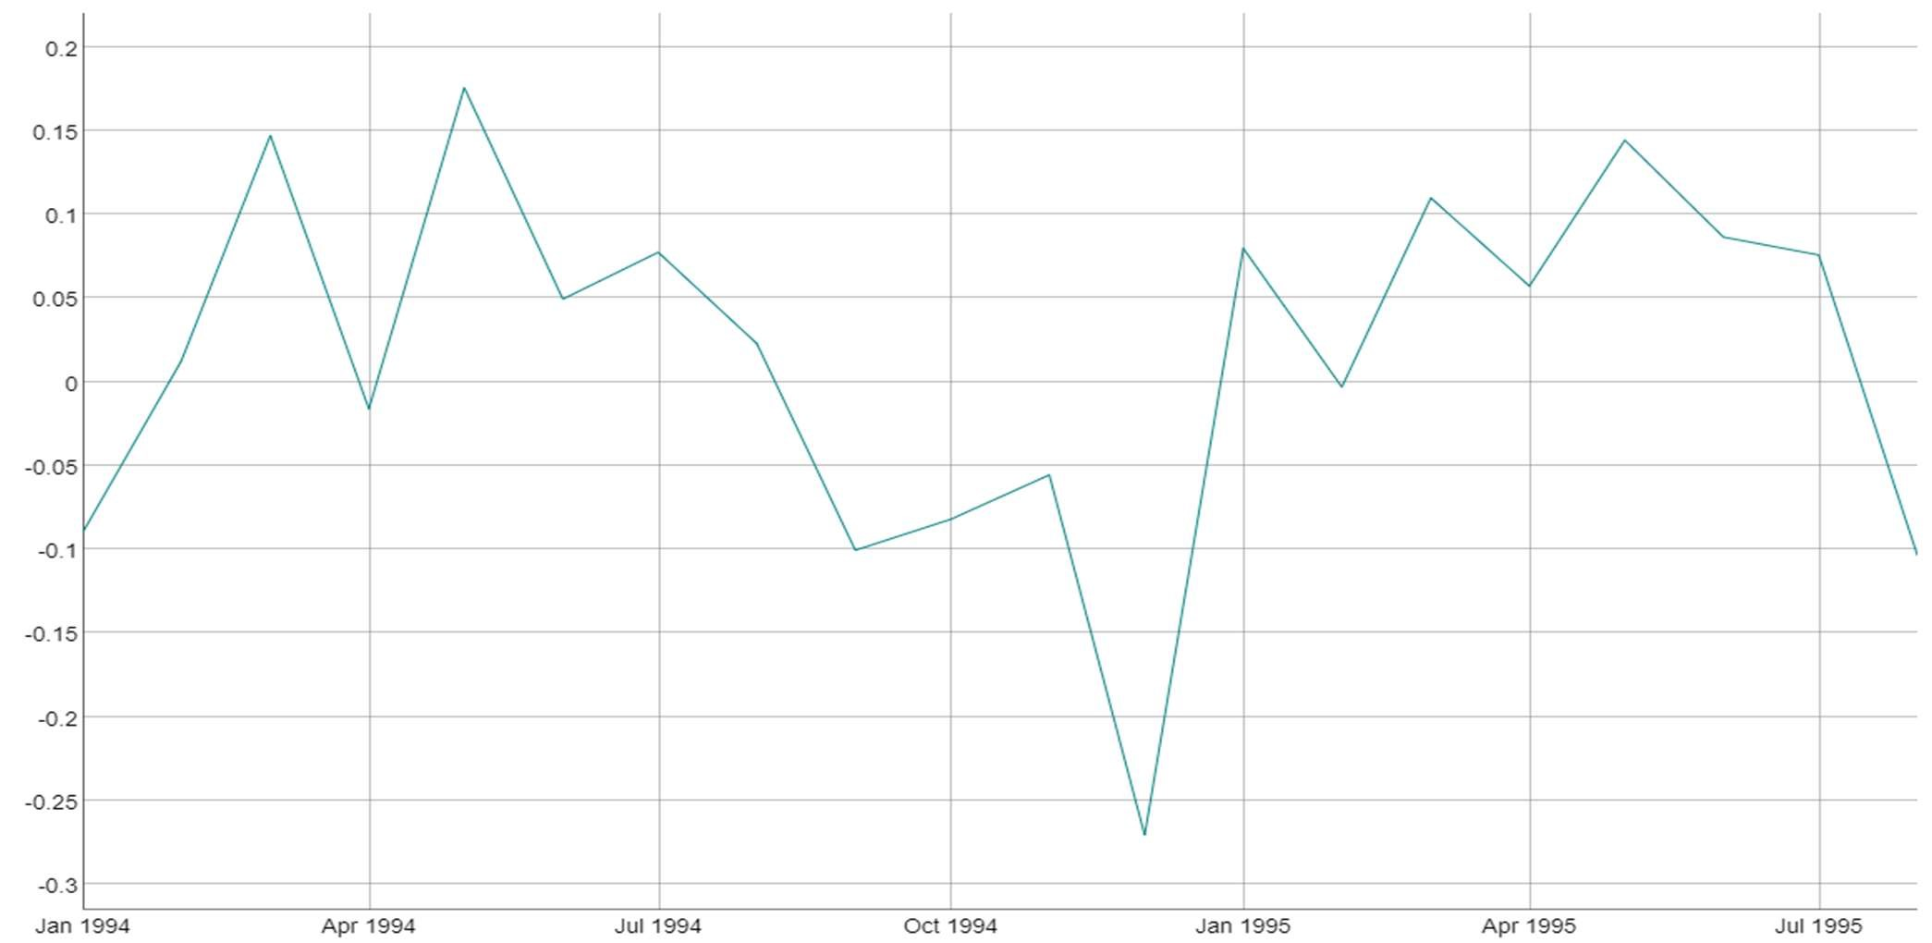

# 9. CHECKING ACF AND PACF ON THE TRAIN SET

RCode:

* acf(train_gas,lag.max = 20)

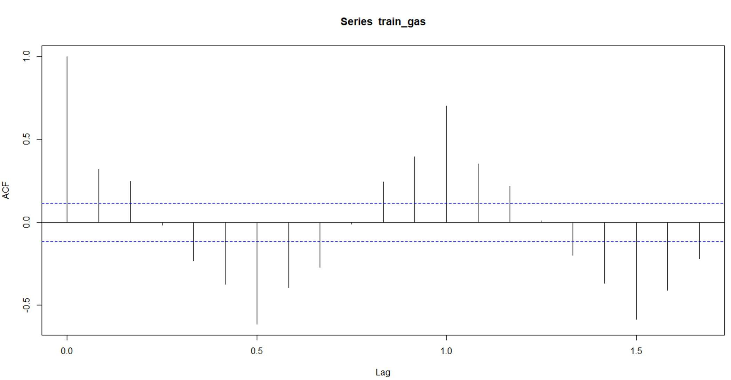

#Value of q= 3

* pacf(train_gas,lag.max = 20)

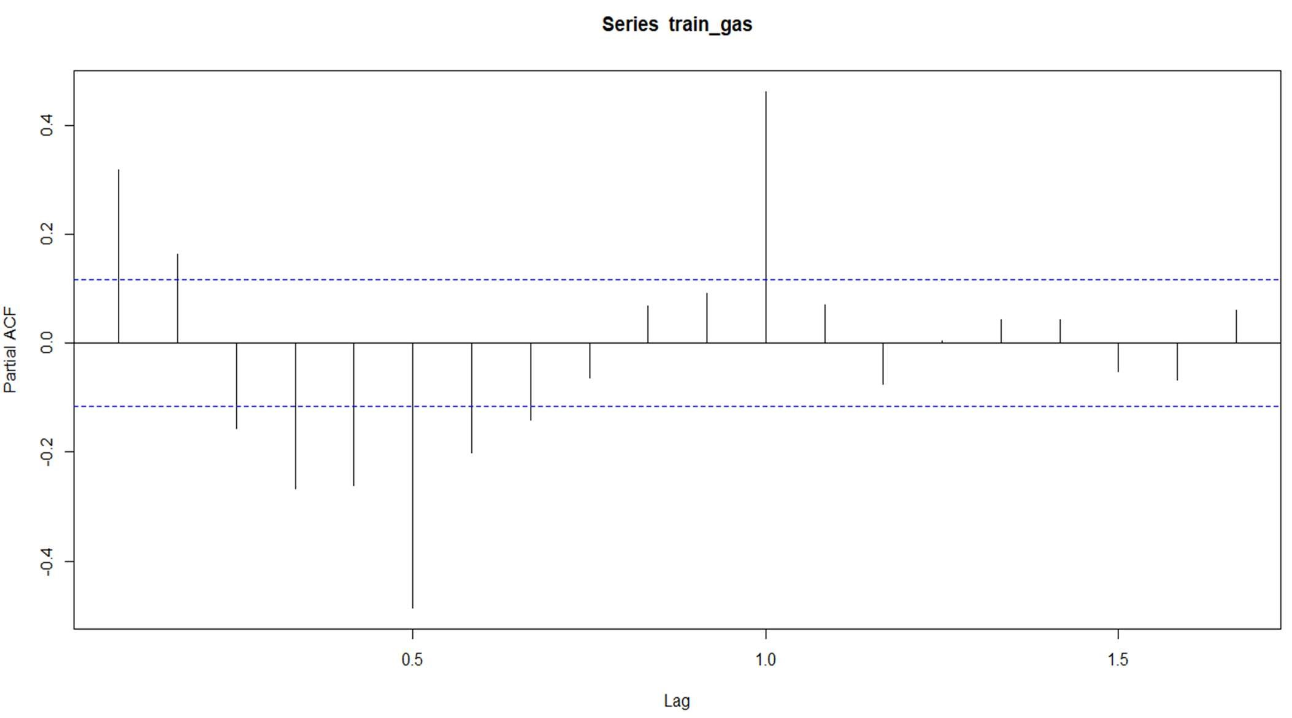

# Value of p= 2

# 10. MANUAL ARIMA MODELLING

It is an Auto Regressive Integrated Moving Average model that explains a given time series based on it past values, its own lags, in order to forecast future values.

10.1 Creating The Manual ARIMA Model

The manual arima takes as argumemts the values of acf , pcaf and differencing in the order of c(p,d,q)

With p=2 nd q=3

RCode:

manual_arima= arima(exp(train_gas), order = c(2,0,3)) summary(manual_arima)

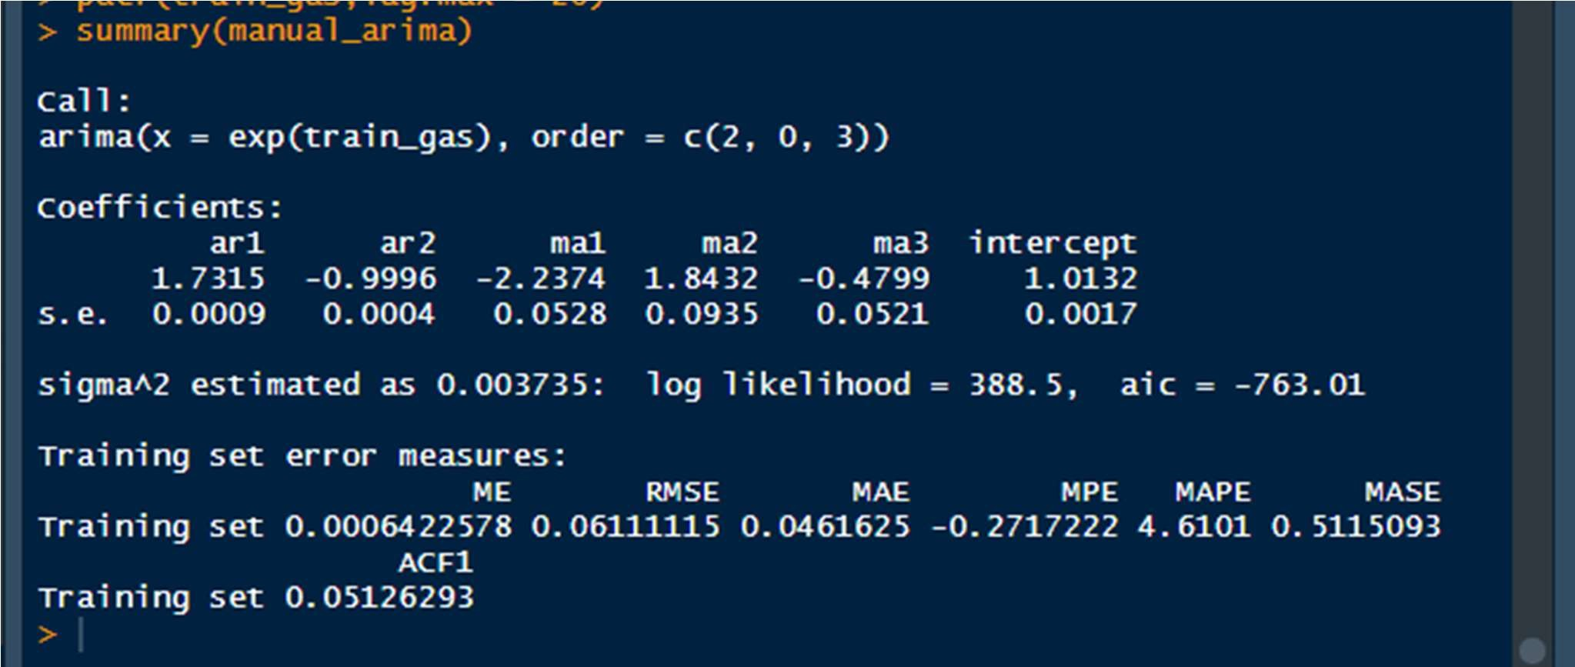

# Aic = -763

## 10.2 Visualizing The Model-Fit

Here, we are visualizing the plots of the actual series alongside the fitted values derived from the model.

Rcode:

manual_fit= fitted(manual_arima)

ts.plot(exp(train_gas), manual_fit, col= c("red","blue"))

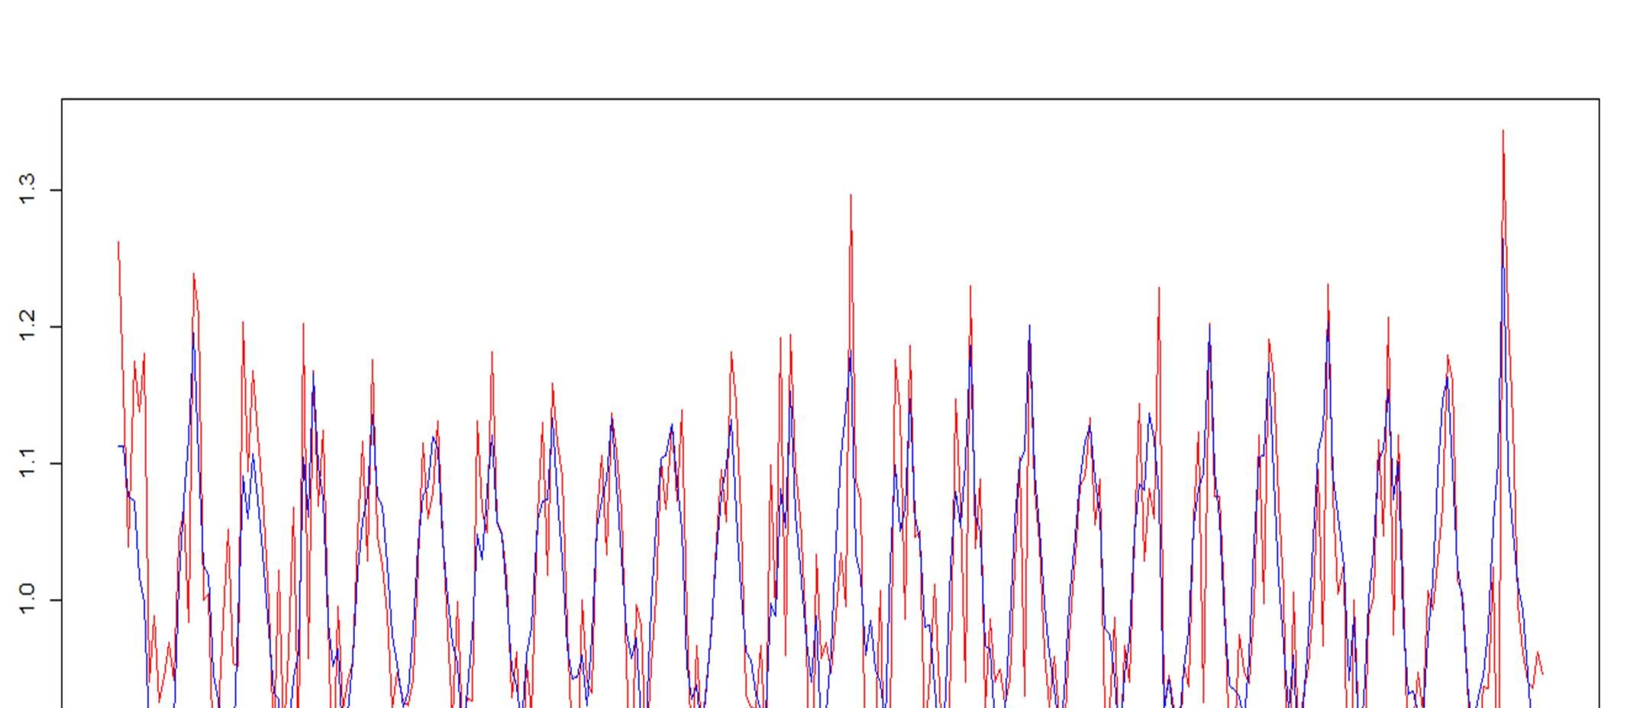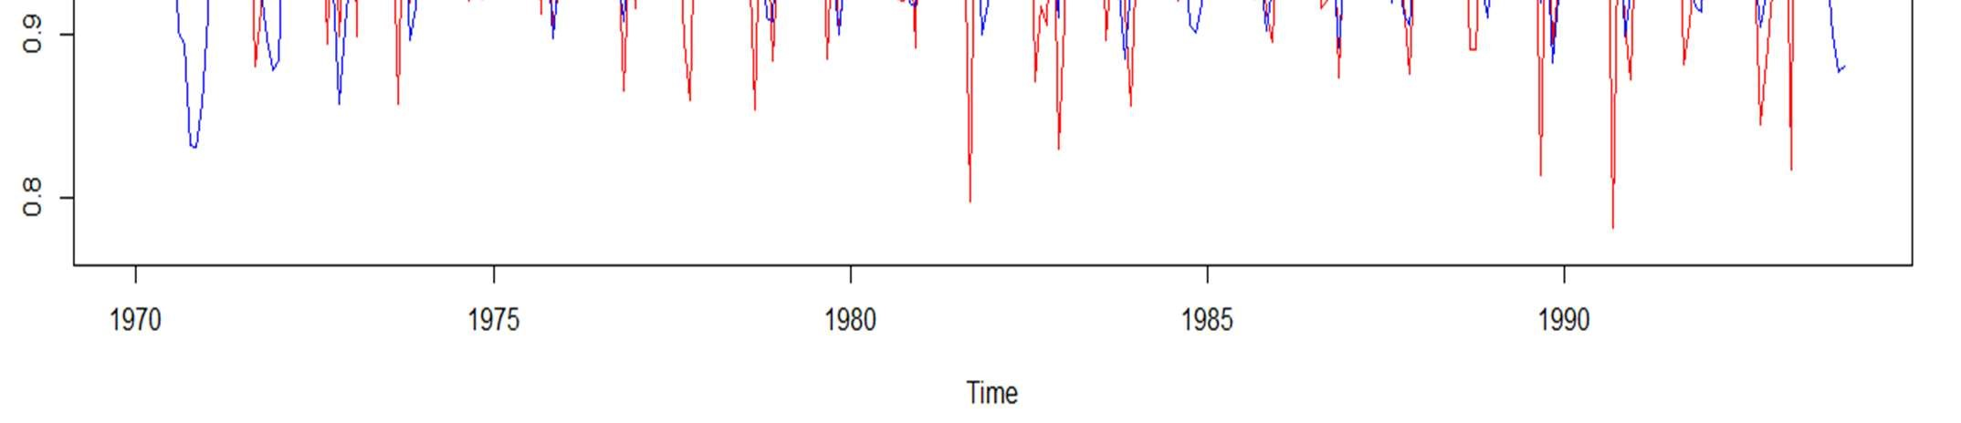

#The model accuracy is quite good as can be observed from the plot. The fitted values are following the curves of the actual values.

## 10.3 Interpreting The Residuals

Here, we will visualize the residuals of the manual ARIMA model that we created.

10.3.1 Using Plots

* hist(manual_arima_final$residuals,col = "purple")

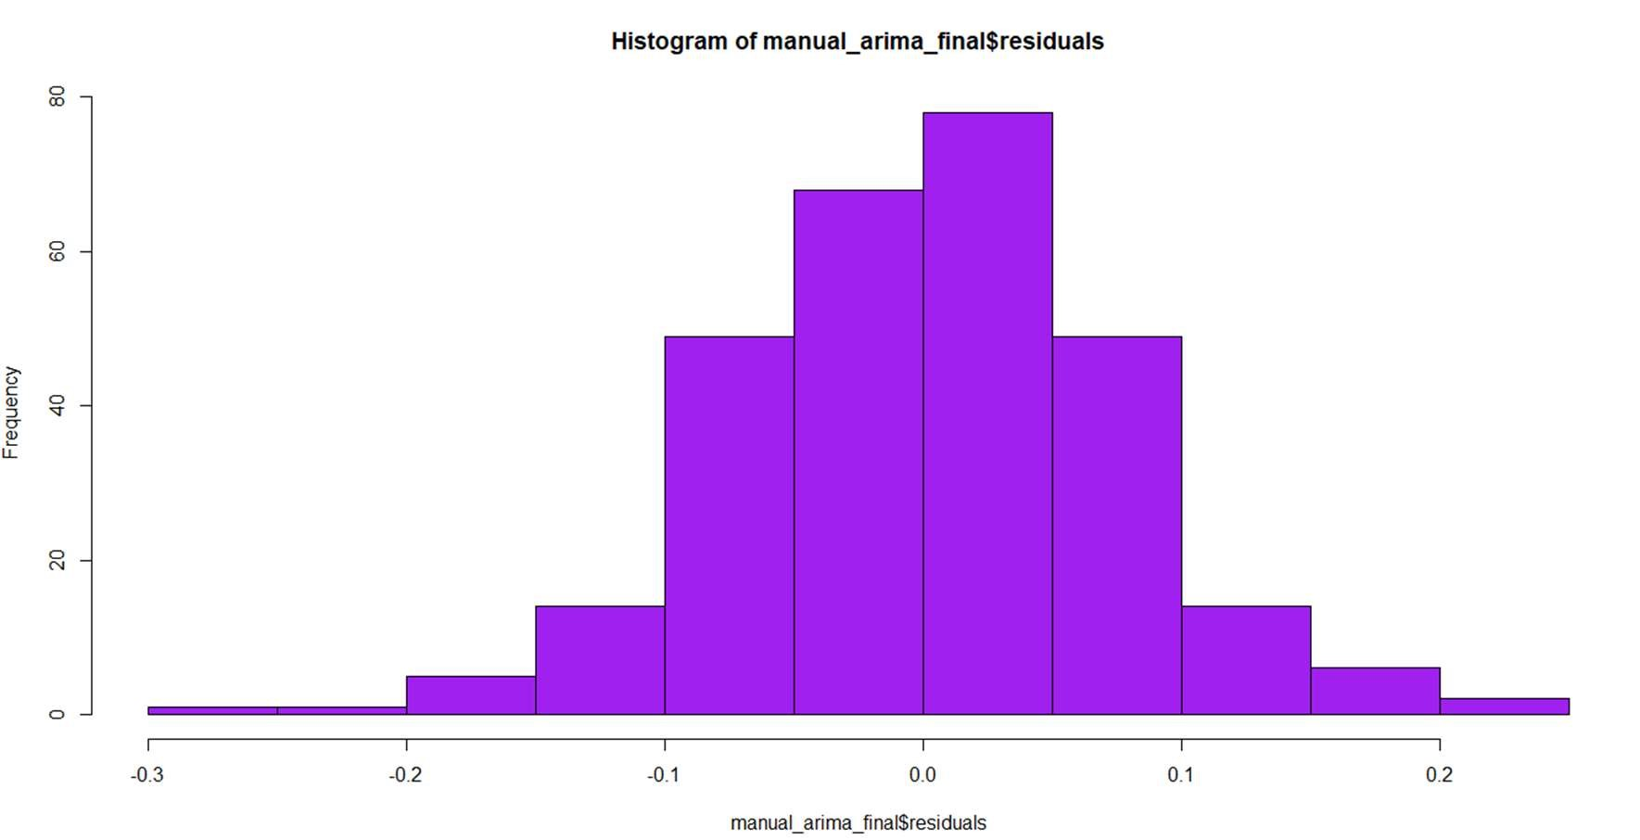

* ggtsdisplay(residuals(manual_arima_final), lag.max = 25, main = "Model Residuals")

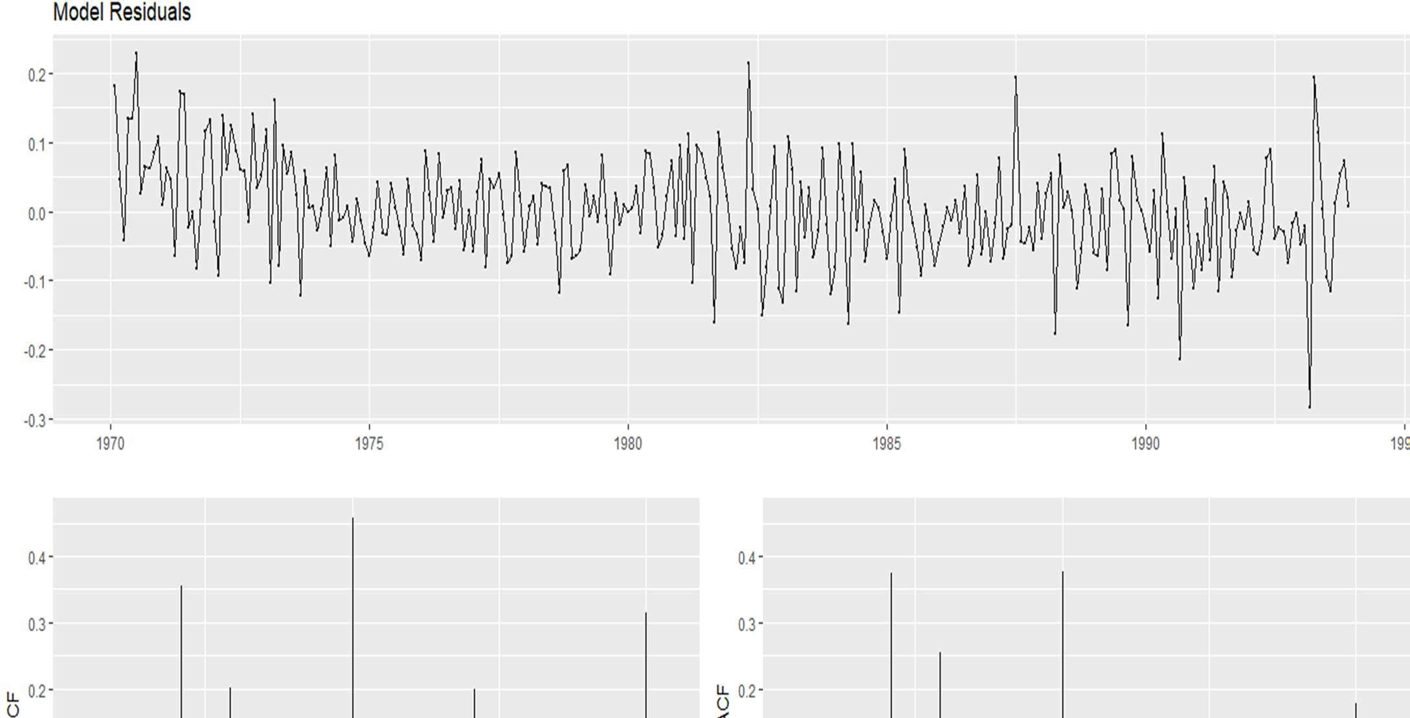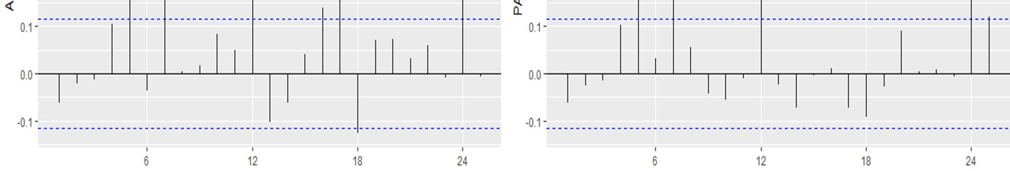

10.3.2 Using Box Ljung Test

This test is used for examining the null hypothesis of independence of residuals in a given time series .

H0 : Residuals are independent

H1 : Residuals are not independent

Box.test(manual_arima$residuals)

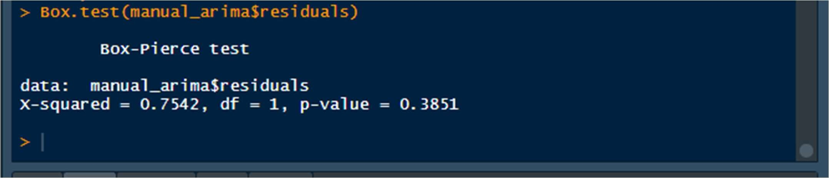

The p-value is 0.385 which is very big as compared to alpha of 0.05.

If p is greater than alpha , we fail to reject the null hypothesis H0.

This results in signifying that THE RESIDUALS ARE INDEPENDENT.

# 11. AUTO ARIMA MODELLING

## 11.1 Creating the Auto ARIMA Model

Whilst using AUTO-ARIMA , we can directly fit our model by skipping the next steps after data preprocessing. It uses AIC and BIC values generated by trying various different combinations of p, d, and q values to fit the model.

Rcode:

auto_arima= auto.arima(exp(train_gas),seasonal = TRUE) summary(auto_arima)

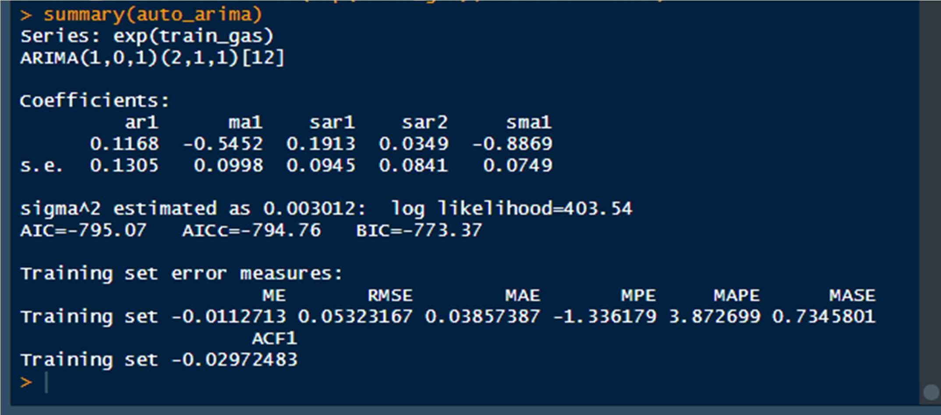

# Aic = -795.07

## 11.2 Visualizing The Model Fit

Here, we are visualizing the plots of the actual series alongside the fitted values derived from the model.

Rcode:

auto_fit<- fitted(auto_arima)

ts.plot(exp(train_gas), auto_fit, col= c("red","blue"))

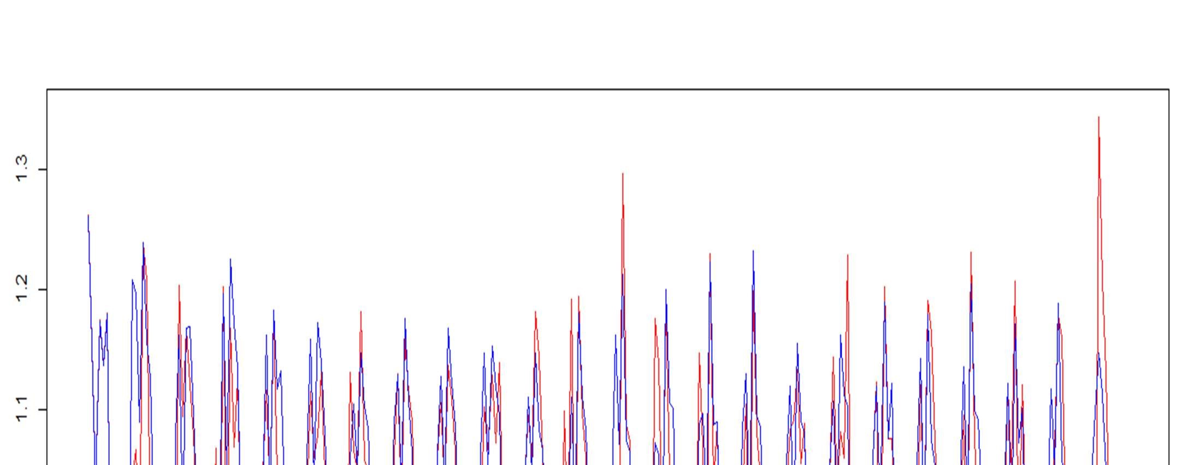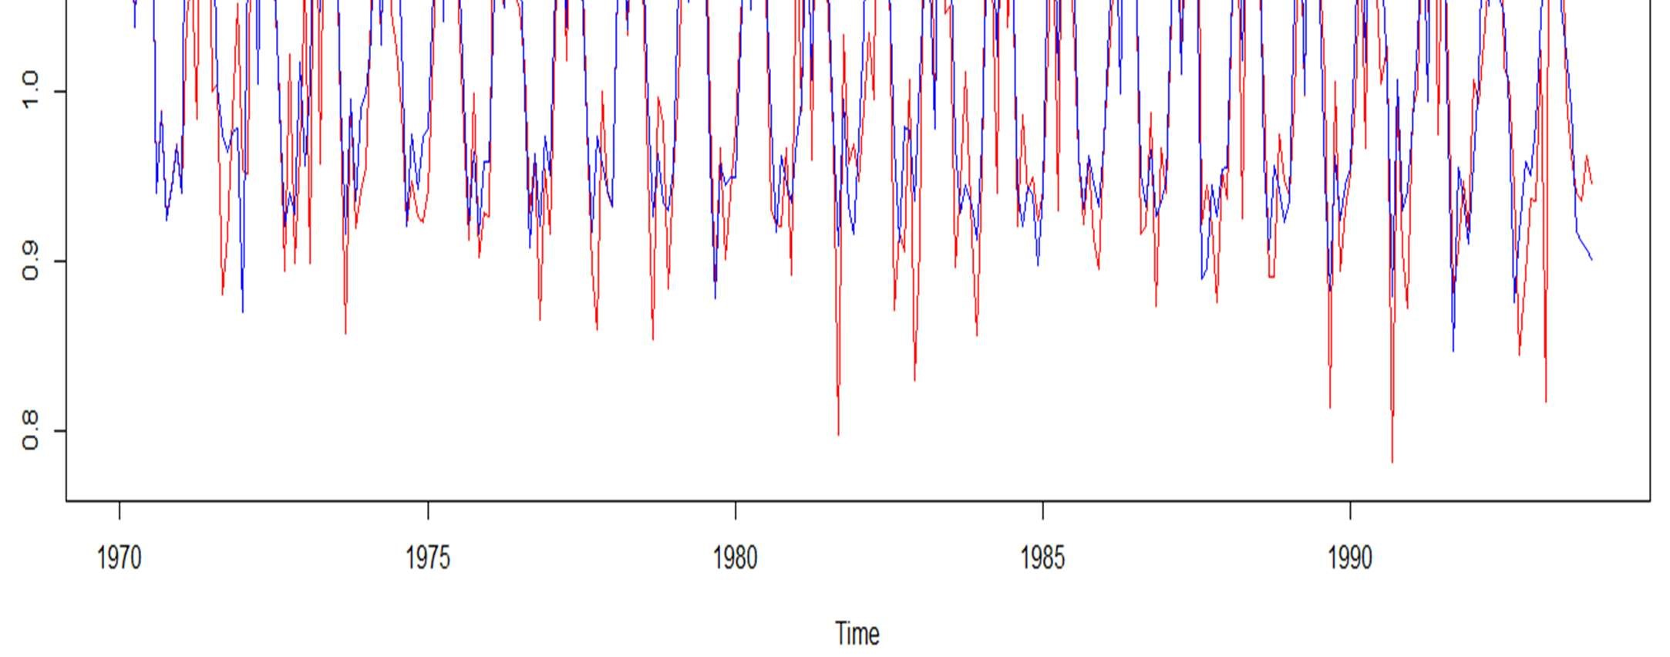

# The model fit seems quite good after visualization. The fitted values are following the curves of the actual values.

## 11.3 Interpreting The Residuals Of The Auto Arima Model

Here, we will visualize the residuals of the manual ARIMA model that we created.

11.3.1 Using Plots

* ggtsdisplay(residuals(auto_arima),lag.max = 10, main = "Residuals")

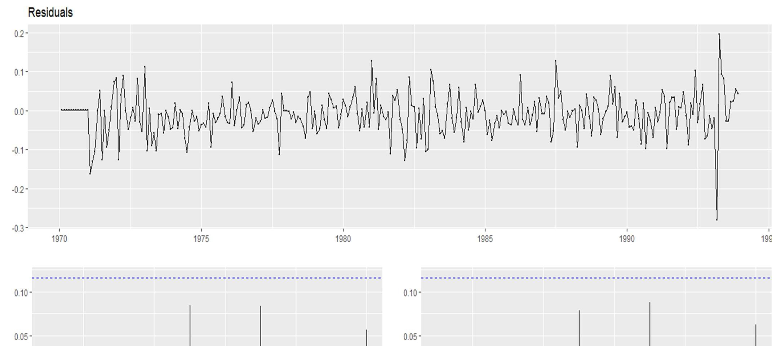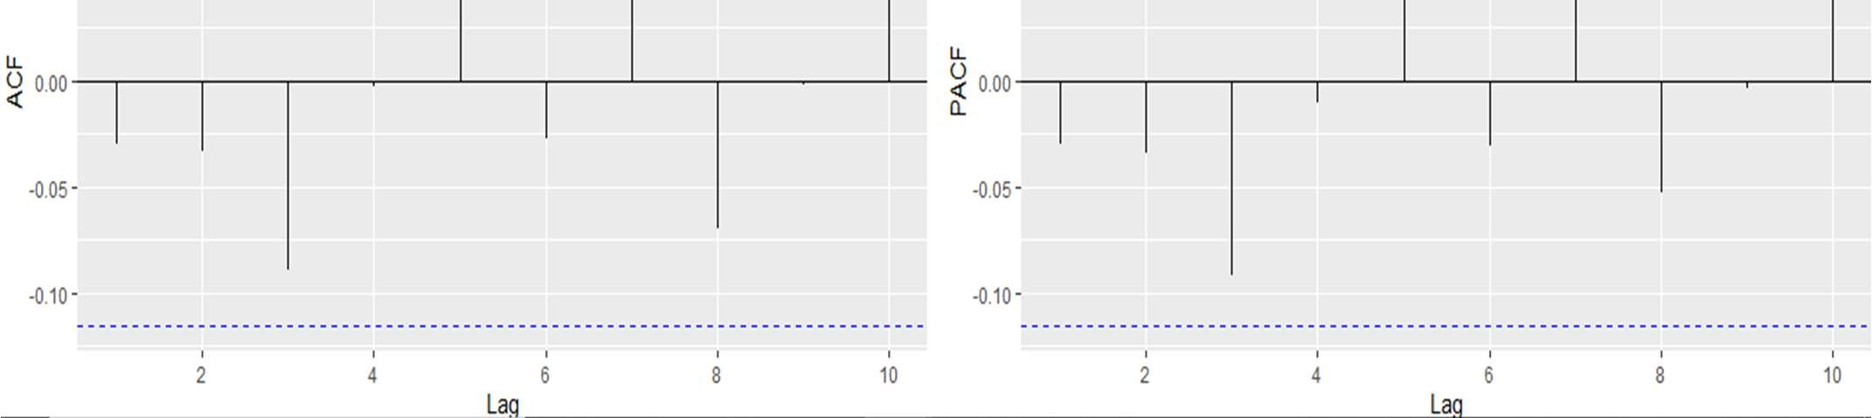

* hist(auto_arima$residuals,col = "purple")

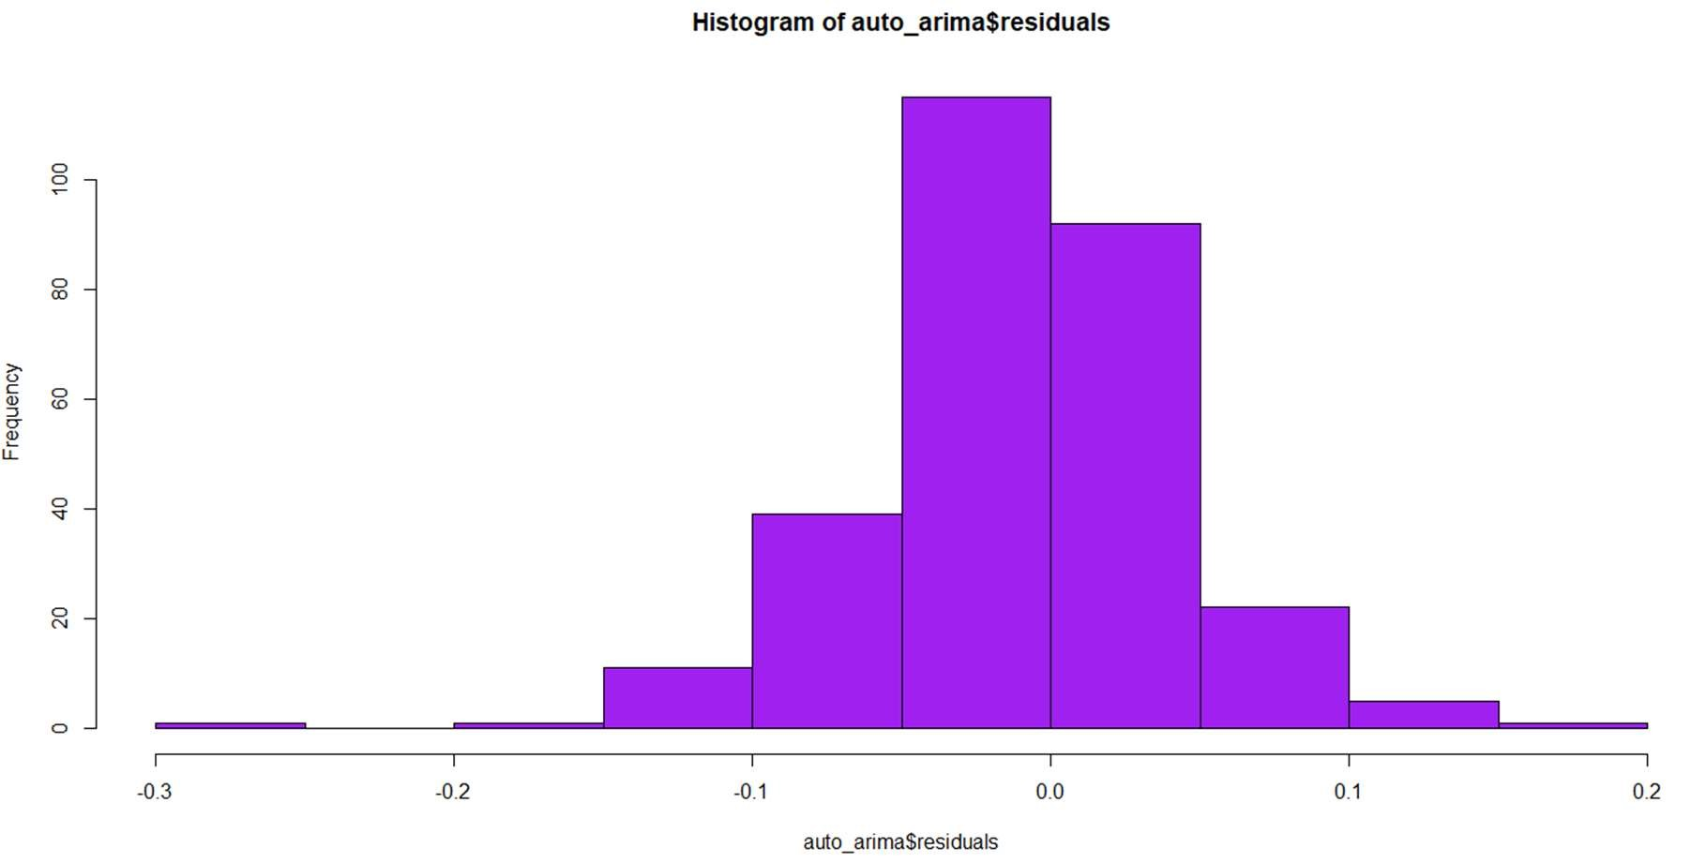

11.3.2 Using Box-Ljung Test

This test is used for examining the null hypothesis of independence of residuals in a given time series .

H0 : Residuals are independent

H1 : Residuals are not independent

RCode:

Box.test(auto_arima$residuals)

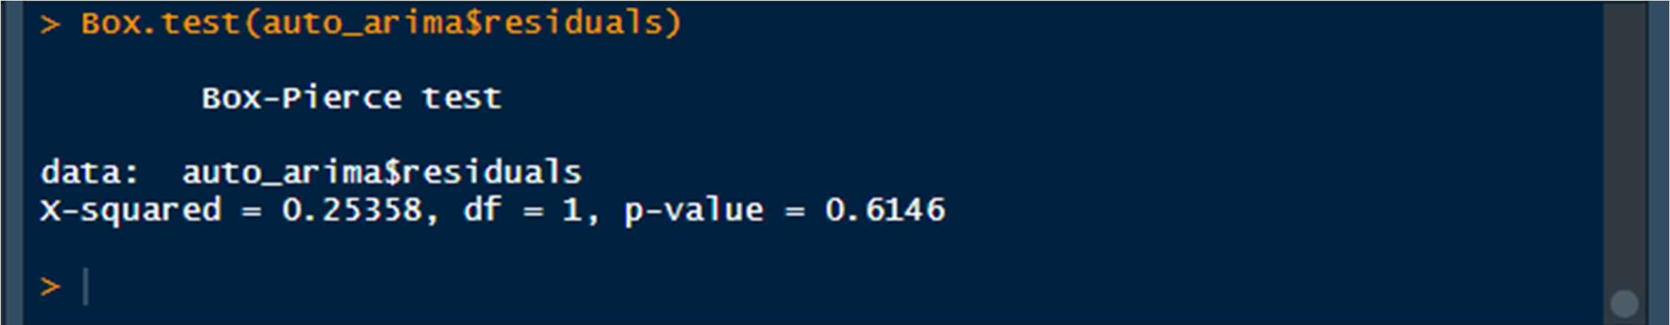

The p-value is 0.614 which is very big as compared to alpha of 0.05.

If p is greater than alpha , we fail to reject the null hypothesis H0.

This results in signifying that THE RESIDUALS ARE INDEPENDENT.

# 12. FORECASTING ON ARIMA MODELS

We have already analyzed the times series and now we will forecast the data using the ARIMA models that we have built

## 12.1 Manual ARIMA Forecasting

RCode:

manual_forecast= forecast(manual_arima,h=20) plot(manual_forecast)

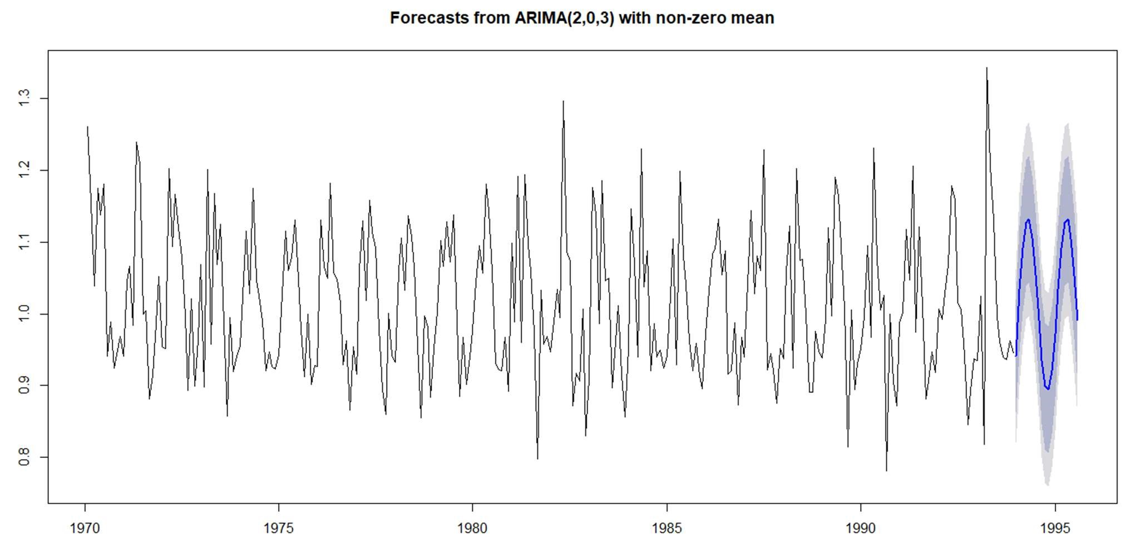

accuracy(manual_forecast,exp(test_gas))

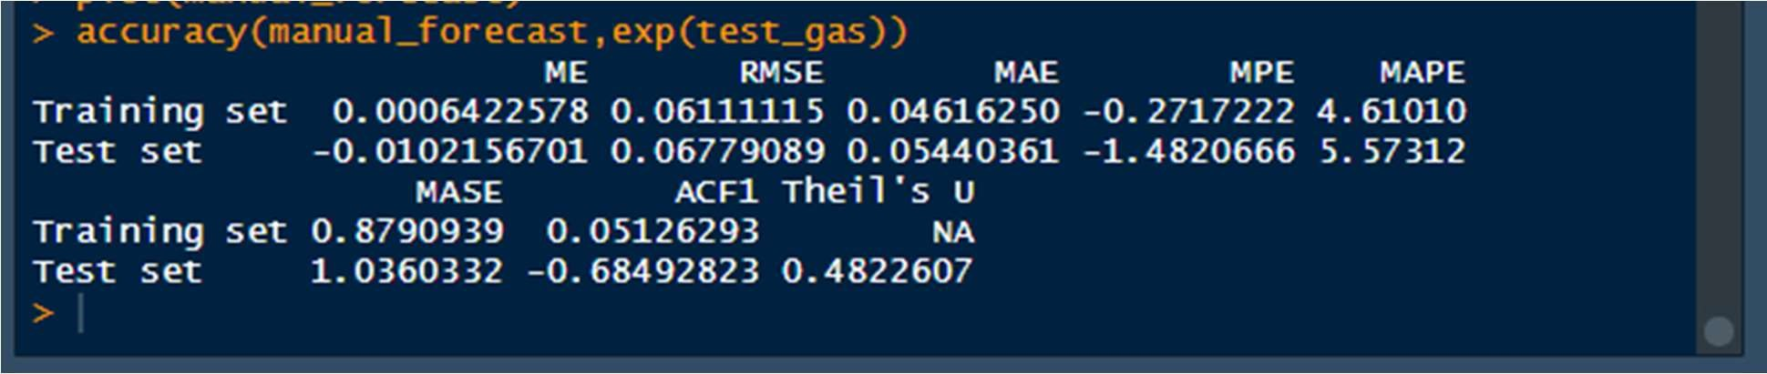

The Accuracy on:

# Train Data= 4.610

# Test Data= 5.573

MAPE on TRAIN: 4.610

MAPE on TEST : 5.573

### ➔ Visualization Of the Actual, Fitted and Forecasted values

test_forecast(forecast.obj = manual_forecast,actual = exp(diff_gas), test = exp(test_gas))

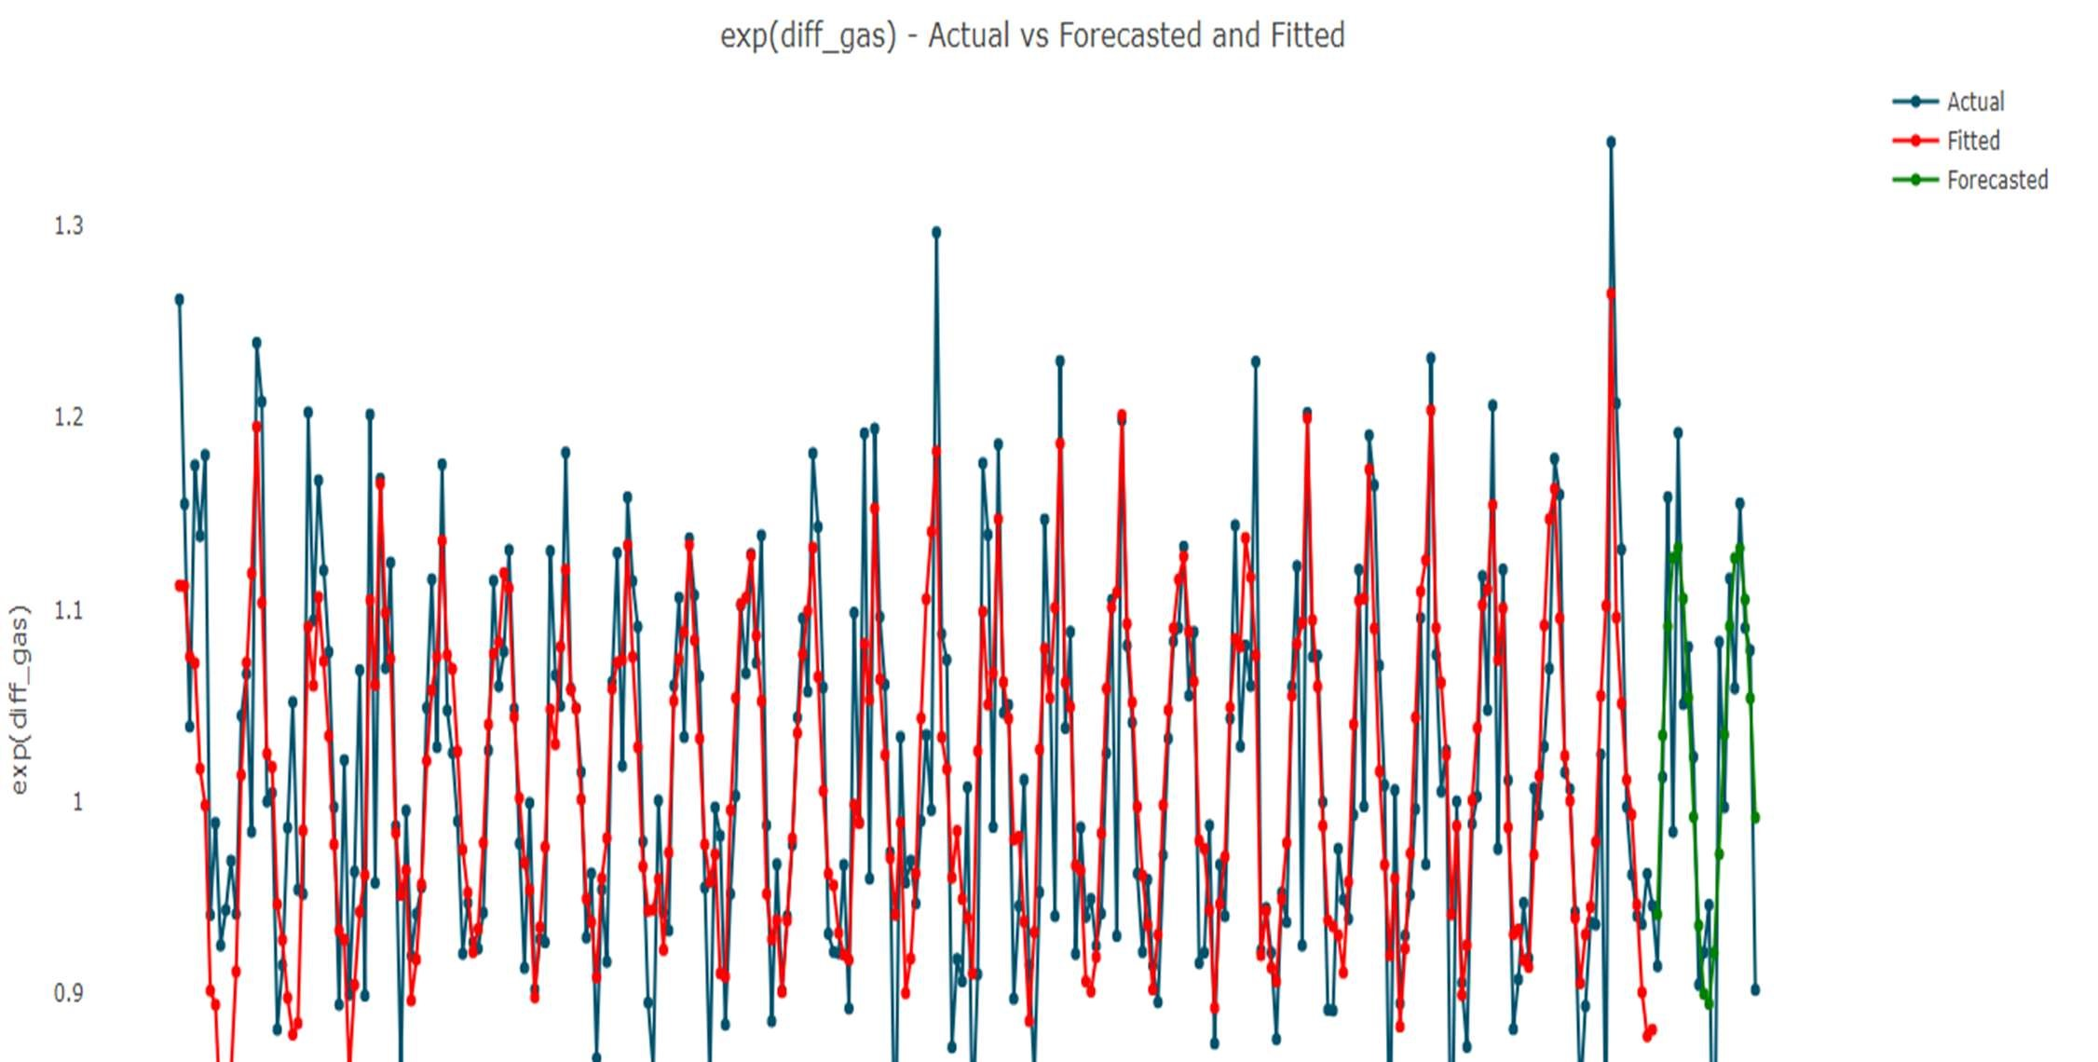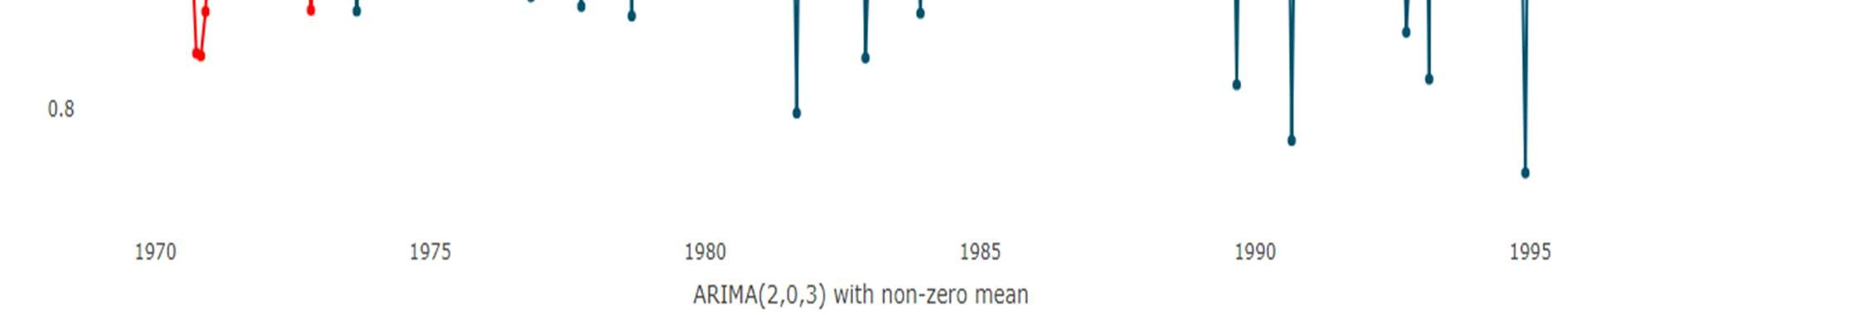

## 12.2 Auto ARIMA Forecasting

RCode:

auto_forecast = forecast(auto_arima,h=20) plot(auto_forecast)

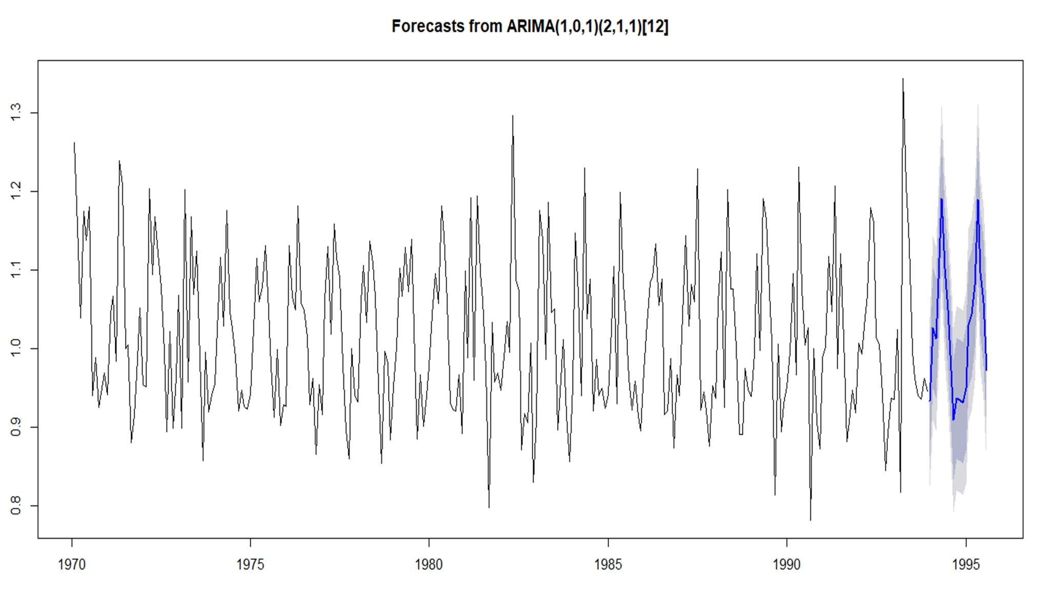

accuracy(auto_forecast,exp(test_gas))

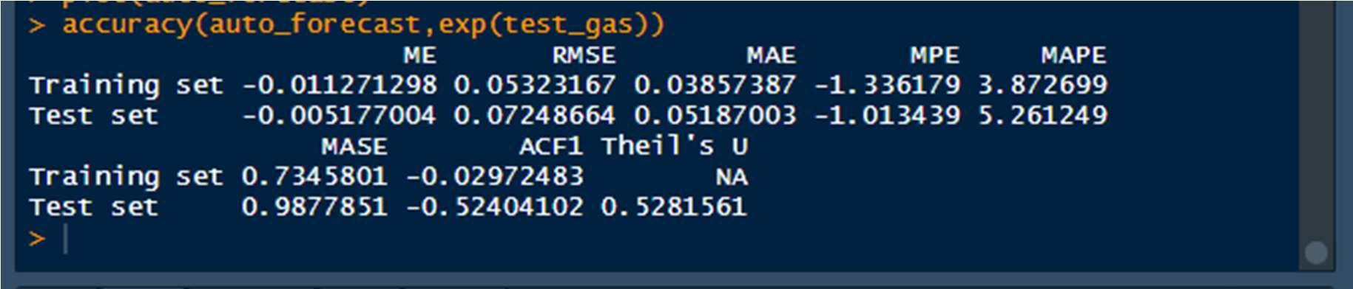

The Accuracy on:

# Train Data= 3.8726

# Test Data= 5.261

MAPE on TRAIN: 3.872

MAPE on TEST : 5.262

### ➔ Visualization Of the Actual, Fitted and Forecasted values

test_forecast(forecast.obj = auto_forecast,actual = exp(diff_gas), test = exp(test_gas))

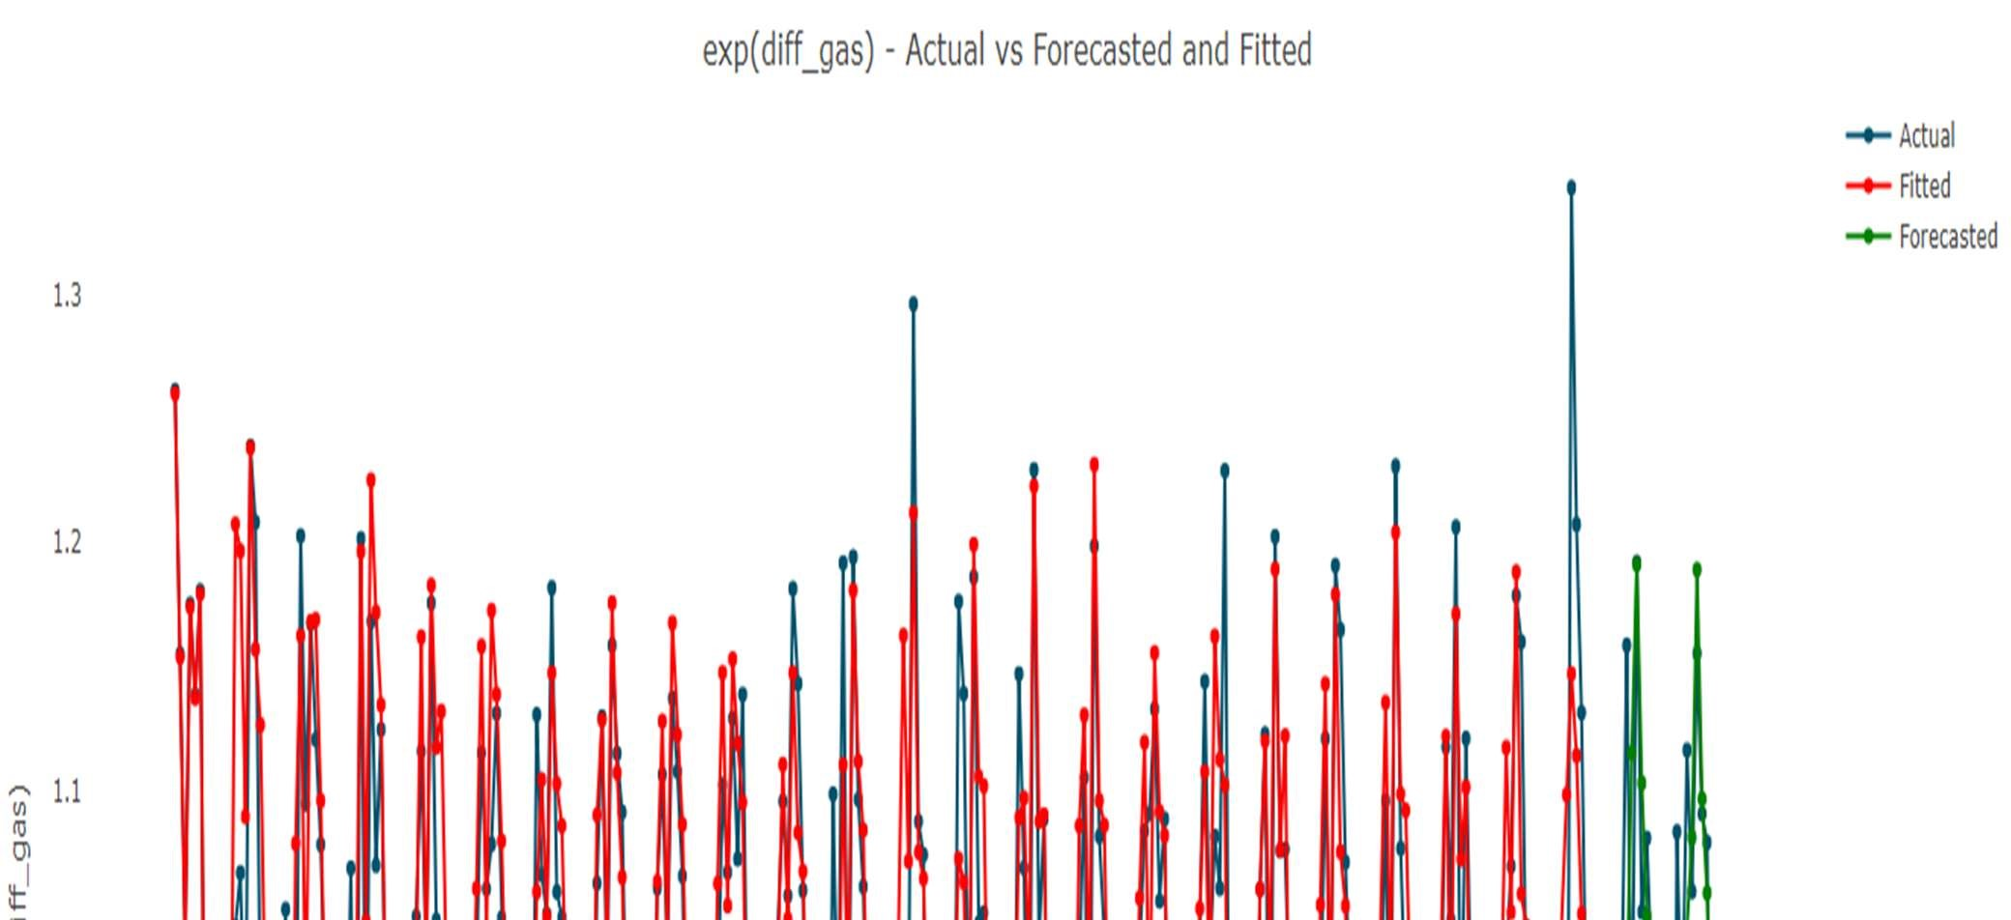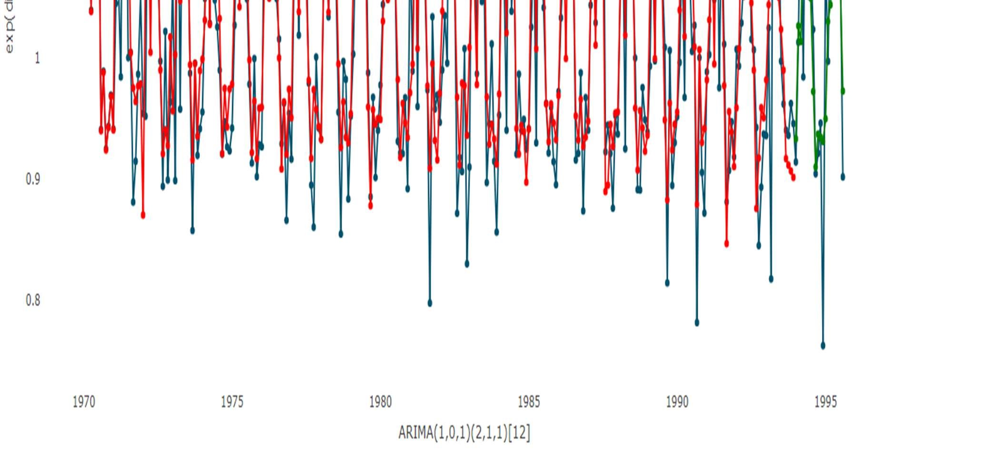

# 13. SELECTING THE FINAL BEST MODEL

We select the best model by comparing the AIC values. Aic is a relative idea. So, the model with the lower Aic value will be selected.

➔ Comparing the AIC values:



# MANUAL ARIMA AIC = -763

# VS

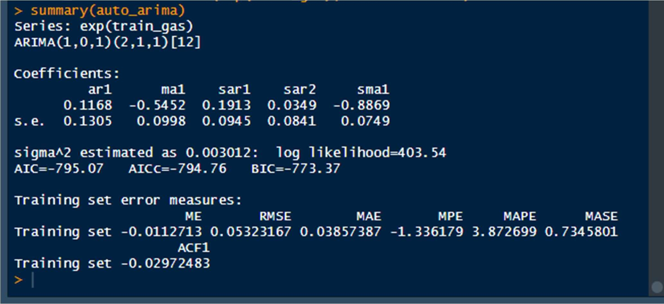

# AUTO ARIMA AIC = -795

AIC is always the lower the better.

So, we’ll chose AUTO ARIMA with (p,d,q) as (1,0,1) as our FINAL MODEL and do the further forecasts of 12 month by using this model.

## ➔ Comparing MAPE Values

MANUAL ARIMA :

#MAPE on TRAIN: 4.610

#MAPE on TEST : 5.573

AUTO ARIMA:

#MAPE on TRAIN: 3.872

#MAPE on TEST : 5.262

From these MAPE values too, we can interpret that the Auto ARIMA model performs better than the manual ARIMA model.

# 14. USING FINAL MODEL TO FORECAST FOR UNSEEN 12 MONTHS

Rcode:

final= forecast(auto_arima,h=32) plot(final)

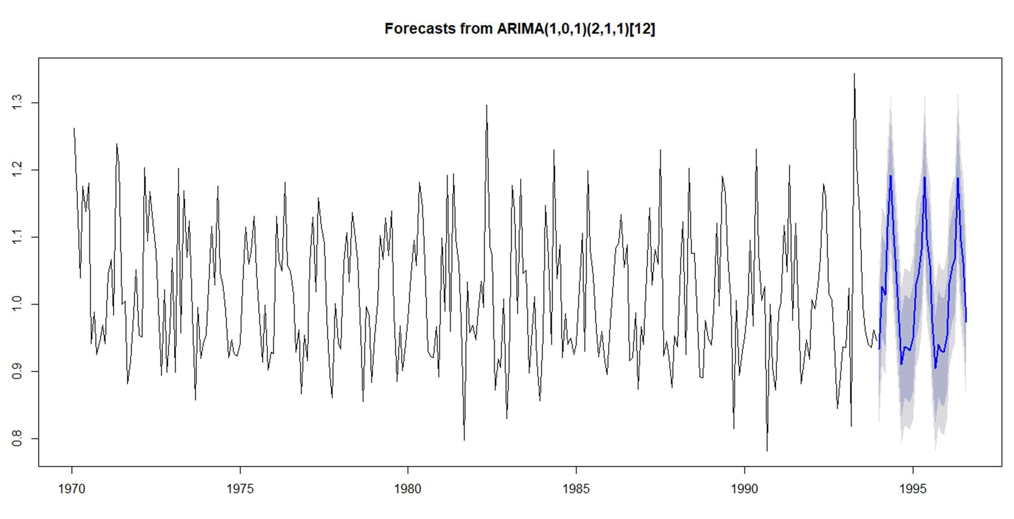

• ts.plot(exp(train_gas),auto_fit,col=c("red","blue"))

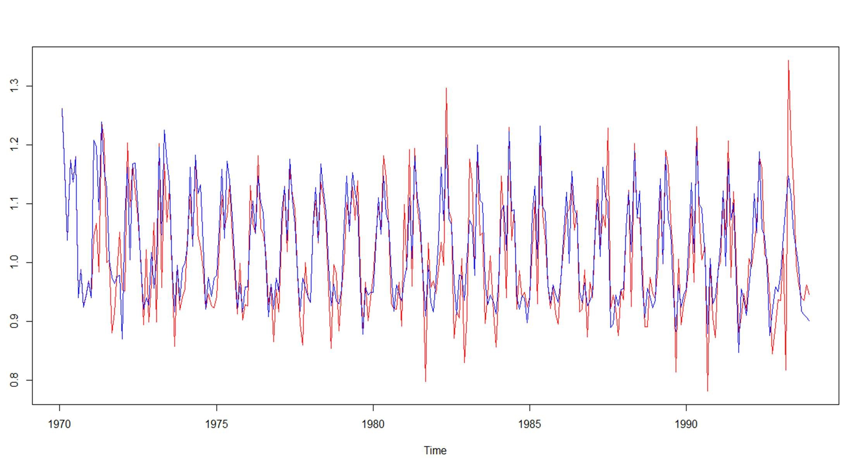

## ➔ Individual plots of the actual and the fitted values

* plot(exp(train_gas),col=c("blue"))

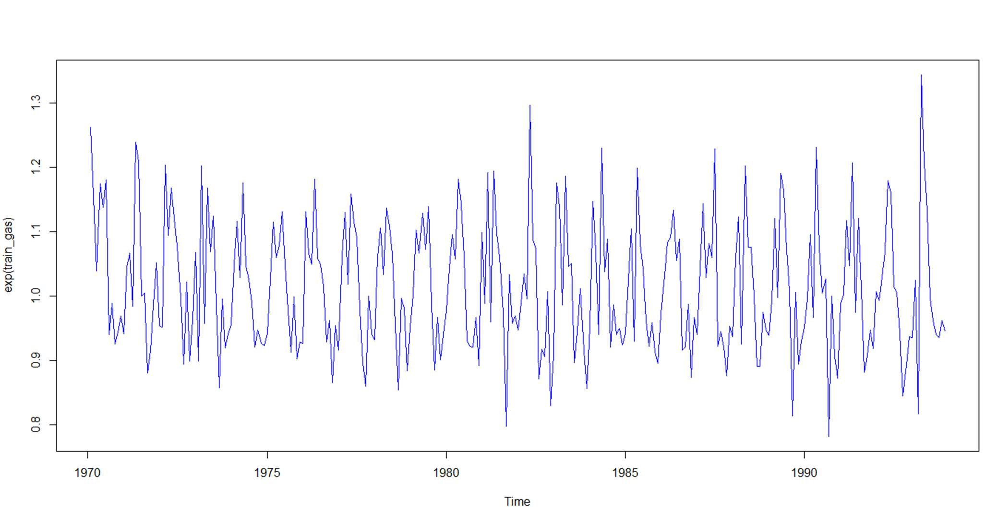

* plot(auto_fit,col=c("blue"))

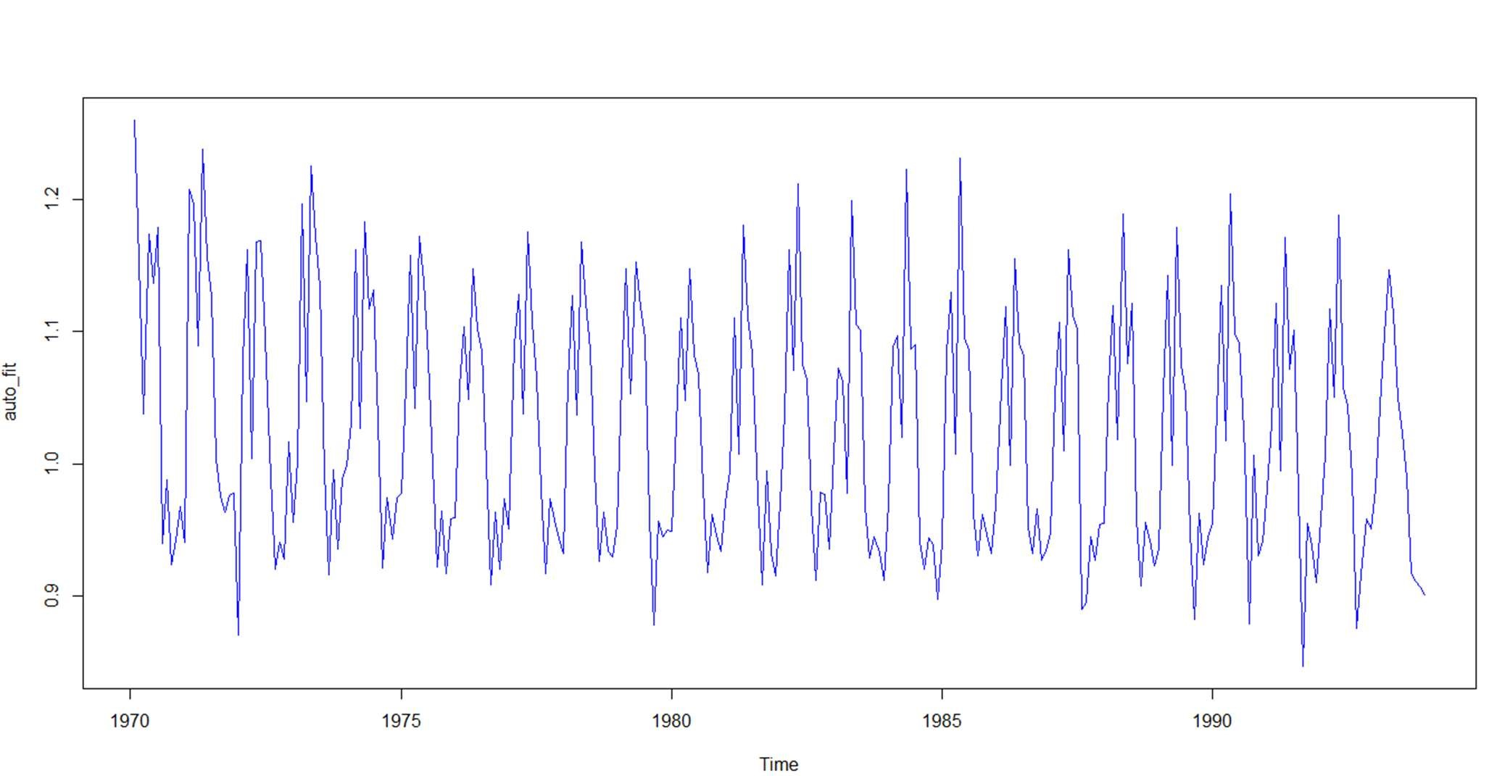

* test_forecast(forecast.obj = auto_forecast,actual = exp(diff_gas),test = exp(test_gas))

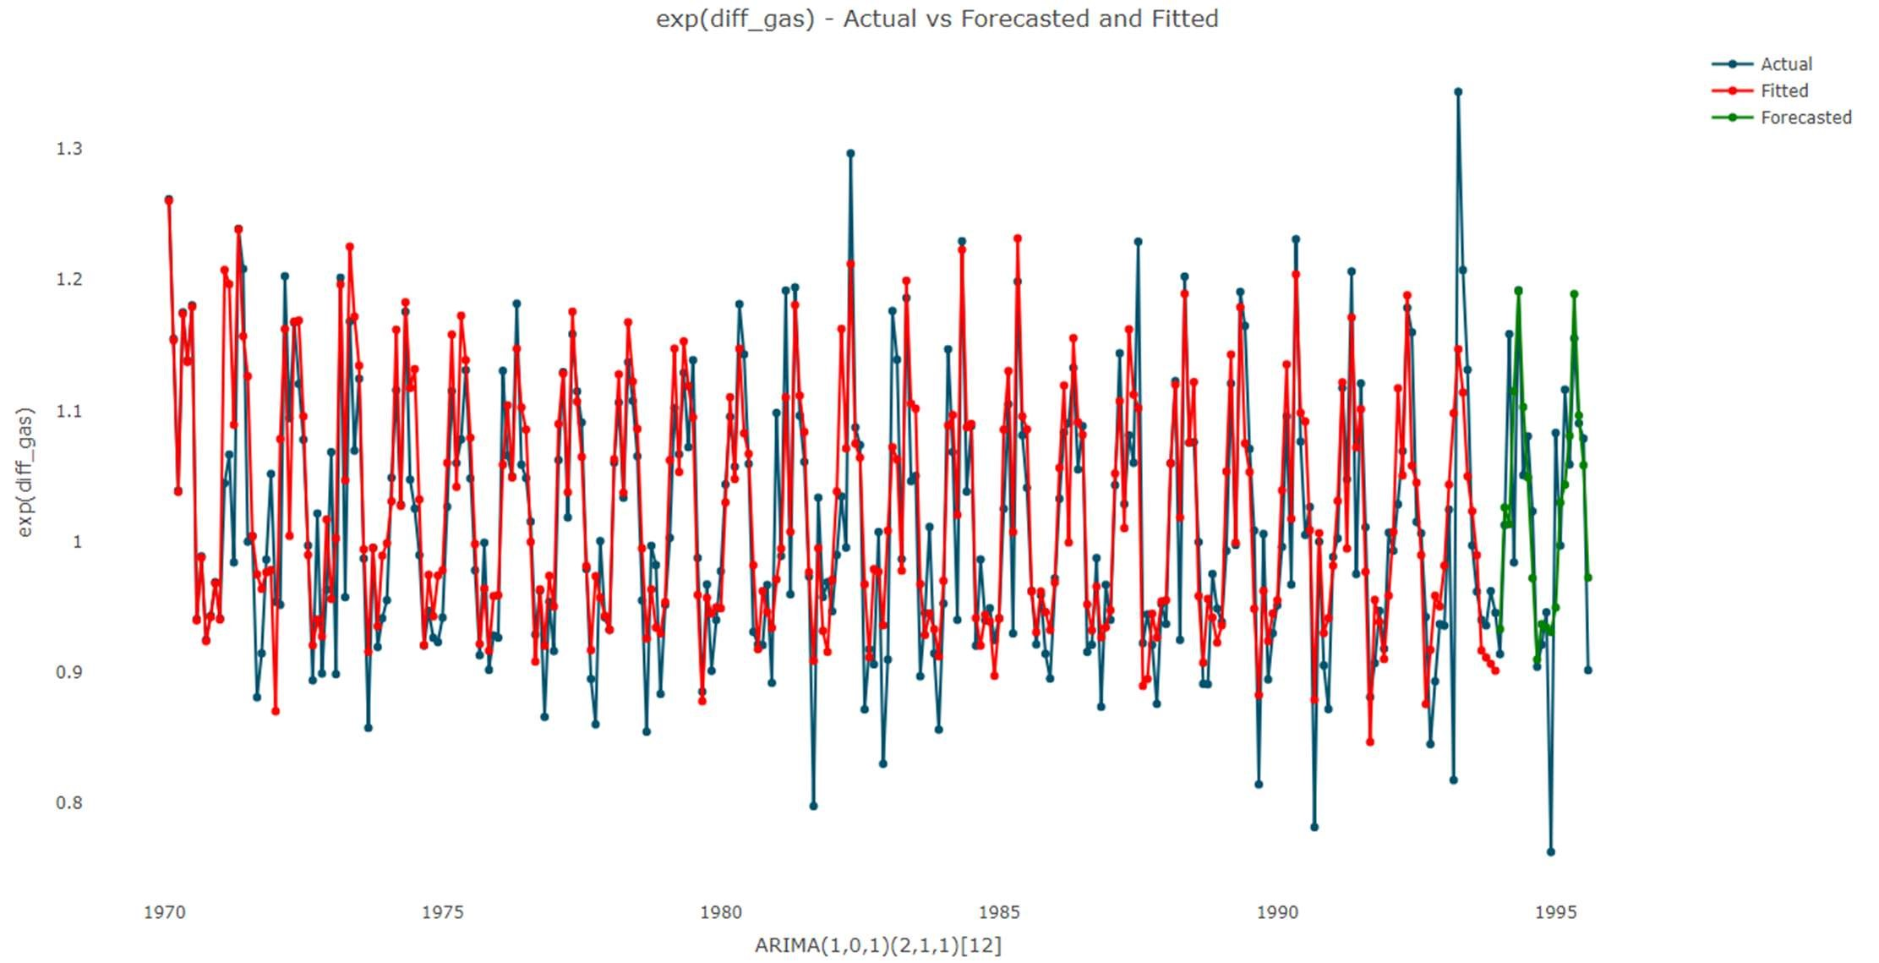

# Forecasted values are:

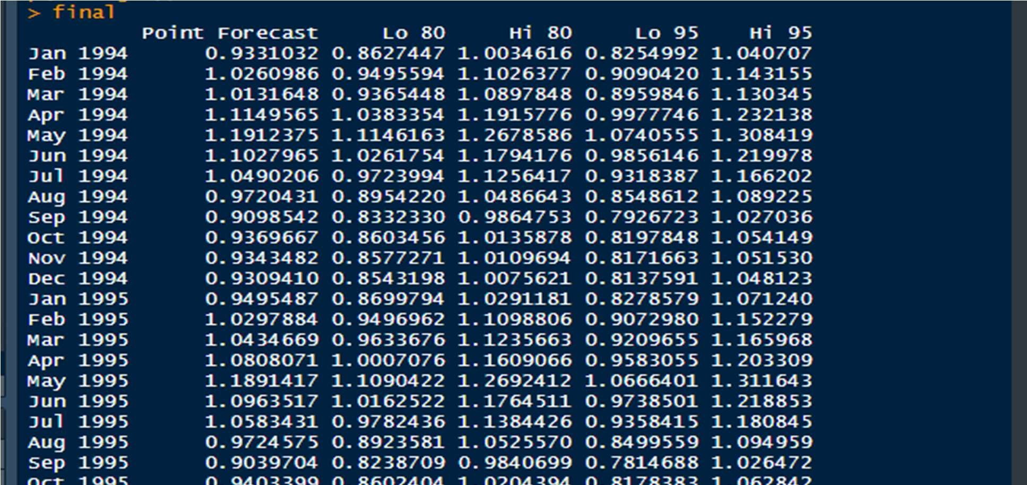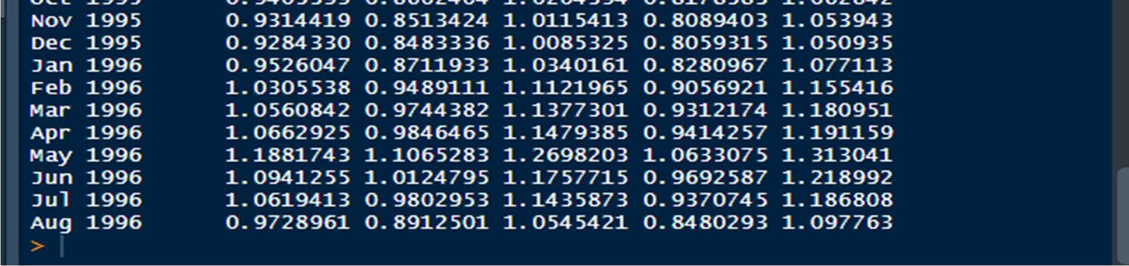

The forecasted values for just the new 12 months are:

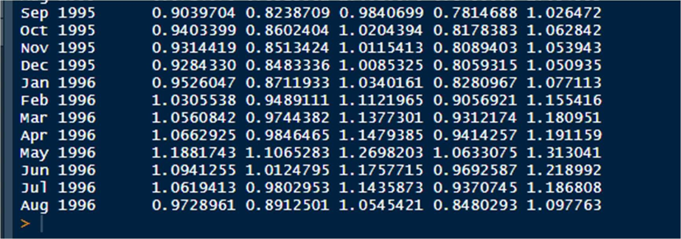

* + Hence, we have derived the forecasted values for next 12 months i.e., from Sep,1995 till Aug,1996
  + We used the Auto ARIMA model that deals directly with our original dataset.

# The Accuracy of the Model is

*MAPE on TRAIN: 3.872

*MAPE on TEST : 5.262

RCODE:

install.packages("forecast") install.packages("tseries") install.packages("dygraphs") install.packages("TTR") install.packages("xts") install.packages("TSstudio")

library(forecast) library(tseries) library(dygraphs) library(TTR)

library(xts) library(TSstudio)

data<- forecast::gas str(data)

summary(data) class(data) gas = window(data, start=c(1970,1), end= c(1995,8)) plot(gas)

#--------------------------------------------------------------------------

#Visualizing the time series plot.ts(gas)

monthplot(gas)

ts_seasonal(gas,type = "all")

boxplot(gas~cycle(gas), main = "Boxplot for Gas Dataset")

#----------------------------------------------------------------------------

# Decomposition of the time series into its different components

decomp_gas= stl(gas_production, s.window = "periodic") plot(decomp_gas)

# Here, we see that Trend plays a very big role in the making of this

# time series. The Residuals are also a significant part if our Time series. # But there is no seasonality component in here. Therefore, we can say that only

# Trend and residual component are present in our time series.

#----------------------------------------------------------------------

# Checking the Periodicity of the Time-series data

periodicity(gas)

#-------------------------------------------------------------------------

# Check the Stationarity of the Series

# Using Augmented Dickey Fuller Test

# Formation of The Hypothesis of Augmented Dickey Fuller Test

# Null Hypothesis : H0: The time series is Non-Stationary # Alternate Hypothesis: H1: The time series is Stationary adf.test(gas, alternative = "stationary",k=12)

# The p-value comes oput to be .84 which is much bigger than the Alpha of 0.05.

# Therefore, we fail to reject the null hypothesis of the series being non_stationary.

# We'll accept the Null Hypothesis stating that the time series is

# non-staionary.

# Using Visual Interpretaion from the Decomposed plots

plot(decomp_gas)

# Had the series been stationary, there would have been no Trend or Seasonality.

# But there is a presence of Trend in the series. Therefore, also visually

# talking , the series is not stationary.

# Therefore, we don't need to deseasonlize the time series because its already

# unaffected by the seasonal component.

# The series is non-stationary.

# Checking the Correaltions acf(gas, lag.max = 100) pacf(gas,lag.max = 20)

#--------------------------------------------------------------------

# Converting the time series into Stationary series.

# using Differencing of the data

diff_gas= diff(log(gas), differences = 1)

dygraph(diff_gas) adf.test(diff_gas, alternative = "stationary",k=12)

# here, we see that the p-value is much lowwer than our alpha of 0.05.

# Therefore, we know thta if P-value is less than Alpha, then we reject the Null

# hypothesis and accept the laterantive Hypothesis of the series being

# Stationary.

# Hence, by doing the differencing og the time series one time, we are able to convert the # non-stationary time series into stationary time-series.

# Now, we'll find out the ACF and PACF for the differenced time series.

acf(diff_gas,main="ACF for Difference Time Series") pacf(diff_gas,main="PACF for Difference Time Series")

# From here , we'll take q=3 as ACf value gives us the value of q to be taken.

# we'll take p=2 as PACF gives us the value of p to be taken.

# Splitting the Time series data set into Train and Test parts.

# We'' use the data from 1970 inthe Training part .

# We'll use the data from 1994 for the test data . train_gas= window(diff_gas,end= c(1993,12)) dygraph(train_gas) test_gas = window(diff_gas, start=c(1994,1)) dygraph(test_gas)

acf(train_gas,lag.max = 20) pacf(train_gas,lag.max = 20) # Therfore, the value of p= 2, q=3

# Creating Manual Arima Models

# The manual arima takes as argumemts the values of acf , pcaf and # differencing in the order of c(p,d,q)

# With p=2 nd q=3 manual_arima= arima(exp(train_gas), order = c(2,0,3))

summary(manual_arima)

# Aic= -763

manual_fit= fitted(manual_arima) ts.plot(exp(train_gas), manual_fit, col= c("red","blue"))

# Interpretation of the Residuals of the mManual Arima Model

hist(manual_arima_final$residuals,col = "purple")

ggtsdisplay(residuals(manual_arima_final), lag.max = 25, main = "Model Residuals")

# Performaning L-jung Box-Test

H0 : Residuals are independent

H1 : Residuals are not independent

Box.test(manual_arima$residuals)

#----------------------------------------------------------------------

# Applying Auto Arima

auto_arima= auto.arima(exp(train_gas),seasonal = TRUE) summary(auto_arima)

# Aic = -795.07

auto_fit<- fitted(auto_arima)

ts.plot(exp(train_gas), auto_fit, col= c("red","blue"))

#-------------------------------------------------------------------------

# Interpreting The Residuals of the Auto Arima Model ggtsdisplay(residuals(auto_arima),lag.max = 10, main = "Residuals")

hist(auto_arima$residuals,col = "purple")

# Performaning L-jung Box-Test

H0 : Residuals are independent

H1 : Residuals are not independent

Box.test(auto_arima$residuals)

# Forecasting with arima model

# Manual Arima Forecasting

manual_forecast= forecast(manual_arima,h=20) plot(manual_forecast) accuracy(manual_forecast,exp(test_gas))

# The Accuracy on:

# Train Data= 4.610

# Test Data= 5.573

test_forecast(forecast.obj = manual_forecast,actual = exp(diff_gas),

test = exp(test_gas))

# Auto Arima Forecasting

auto_forecast = forecast(auto_arima,h=20) plot(auto_forecast) accuracy(auto_forecast,exp(test_gas))

# The Accuracy on:

# Train Data= 3.8726

# Test Data= 5.261

test_forecast(forecast.obj = auto_forecast,actual = exp(diff_gas),

test = exp(test_gas))

#-----------------------------------------------------------------------

# The auto arima performs better than manual Arima

# Forecasting on 12 months ahead final= forecast(auto_arima,h=32)

plot(final) ts.plot(exp(train_gas),auto_fit,col=c("red","blue")) plot(exp(train_gas),col=c("blue")) plot(auto_fit,col=c("blue"))

test_forecast(forecast.obj = auto_forecast,actual = exp(diff_gas),test = exp(test_gas))